Nature school management based on religious culture

A.K. Masaong, H. Tipuwo & S.R. Mas

Universitas Negeri Gorontalo, Gorontalo, Indonesia

**ABSTRACT: This research aims to describe (1) the management of a nature-based learning in Bubohu Private Vocational High School of Tourism in Gorontalo; (2) the integration of religious culture on the learning process; (3) the educational values contained in the learning process based on religious culture; and (4) the preservation of wood fossil museum as a learning resource. This study uses a qualitative approach with case study design. The research results shown: (1) the learning management applied in the school is a natural-based scientific learning approach that utilizes nature as space, media and learning object; (2) The integration of religious culture values in learning is held from the start to the end of learning activities; (3) the educative values embodied in nature-based learning include the values of: religious, creativity, patriotic, reading fondness and environmental concern; (4) wood fossil museum is used as learning resource for students, society and as research object.**

# INTRODUCTION

The school of nature is one of the alternative models of School-Based Management (SBM). In the process of learning, the school utilizes nature as space, media and learning objects. The learning method of the school of nature uses learning approach based on experience (learning experience). Through this method, participants are invited to do various activities, both inside of school and outside of school. With the various activities, the learning process takes place actively, innovatively, creatively, effectively and fun.

Bubohu Private Vocational High School of Tourism is a private vocational high school in the district of Kabupaten Gorontalo, province of Gorontalo, Indonesia, which the focus of the development is in the field of tourism. The school is under the auspices of the *Walimah* Gold Foundation whose the existence characterized by a nature school because of the physical condition of the school and the system which built on nature. Most of the learning activities are carried out outside of the classroom. The learning activities is carried out in the outdoors and in *wombohe* (typical huts of Gorontalo) that built around the school or outside like on the beach. This is in accordance with research conducted by Robert A. Montgomery and Kelly F Millenbah (2011) shows that students who study outside the classroom are significantly better than students who study in the classroom.

In addition to the nature-based, the school sekolah also integrates the value of religious culture in the learning activities by providing the moral education that is integrated in the school activities. The students of the school are also familiarized to do religious culture so as to form a strong character. The positive culture that is taught and has become a habit in the school is 3S culture (*Senyum* (smile), *Salam* (salutations), *Sapa* (greetings)), praying dhuha and dzuhur in congregation, dhikr and shalawat together, the culture of BATU (*Baca Tulis* (reading writing)) and guiding practice. All students are required to participate, as it has become the programs of the school.

To increase the religious values, at night, the school conducts the recitation of Al-Quran activities at Pesantren Alam Bubohu. In addition, students are also taught various cultures in extra-curricular activities to preserve the culture of Gorontalo. Reciting Al-Quran, the Muslim holly book, is conducted to equip the students and the surrounding community about the science of religion, so that the mission of the school not only produce a knowledgeable output but also the noble character.

Another uniqueness of Bubohu appears on the school concept that combines elements of nature, history, culture and religious values which are very thick, thus creating a nature school that not only explore nature as a place and media of learning, but also loaded with historical, cultural and Religion that is packed into a unique unity because it becomes the first and only one in Gorontalo Province.

This study aims to describe: (1) the management of nature-based learning (2) integrating the values of religious culture on (3) the educational value contained in the process of learning based on religious culture, (4) preservation of wood fossil museum as a learning resource at Bubohu Private Vocational High School of Tourism.

The results of this study support the research conducted by Theodore S May (2004) concluded that the quality of learning outside the classroom provides a very valuable experience for students. It can be interpreted that nature-based learning conducted outside the classroom can improve students' understanding of the material presented by the teacher.

Focus of this study is observing and analyzing the achievement of Bubohu in their implementation of nature-based learning method which is integrated with the religious school culture values in their students learning and daily activities.

# THEORETICAL STUDY

The school of nature was first established in Indonesia in 1997 which was the brainchild of the former State-Owned Enterprises Ministerial staff, Mr. Lendo Novo, an alumnus of Petroleum Engineering of Institut Teknologi Bandung Institute (ITB). The background of the establishment of a school of nature is because of concerns about the educational world that is considered not able to develop the potency of students optimally, and it has not been able to organize learning activities that are fun and unable to produce the graduates who have moral integrity. This shortcoming is part of the educational problems faced by this nation.

This is confirmed by Priatna (2016) which states that the problems of education that Indonesia faced generally are matter of equity, quality, relevance, efficiency, quality, management, and financing of education. That problems occur in nearly every track, level, and type of education. Many factors lead to the educational problems, include the quality and quantity of the learners, the staffs, the curriculum, the educatioanal facilities, community participation, management, and financing.

Educational problems caused by the factor of quality and quantity of learners become the main thing that should be resolved because learners are the core of education itself. This is in line with the statement of Organization for Economic Cooperation and Development (2017) that the learning environment recognises the learners as its core participants, encourages their active engagement and develops in them an understanding of their own activity as learners. Learners are the central players in the environment and therefore activities centre on their cognition and growth. Learning activities allow students to construct their learning through engagement and active exploration. The potensials that do not develop optimally and the learning environment that is not conducive and fun will affect the quality of the learners. This is the basis for the birth of school of nature as the problem solving.

In accordance with the National Juridical Education Foundation of Indonesia (*Landasan Yuridis Pendidikan Nasional Indonesia*) emphasized specifically that the definition of education as a conscious and planned effort to create an atmosphere of learning process so that the students are actively developing their potential to have spiritual strength, self-control, personality, intelligence, noble character, and skills needed by himself, society, nation and state (Departemen Pendidikan Nasional, 2003). According to the definition of education, the school nature is able to create what they want to achieve.

The basic concept of nature school is based on Al-Quran, Al-Hadith and the life of Rasulullah SAW. In terms of curriculum, the school of nature not only stimulates the academic aspect, but also provides the provision of morals and leadership. These pillars (moral-science-leadership) believed to be an important provision that should be owned by every human being to be able to fulfill their duty as caliph who bring mercy to all creatures.

The learning method of school of nature uses experiential learning approach. Nature school is interpreted as learning through direct experience (or ‘doing’) and becomes the integral part of successful learning across all stages of life, from infancy to the senior adult years. Close observation of nature or naturally occuring phenomena stimulate the curiosity of students, enhance their attention to detail, and compel them to confront their existing understandings in light observable evidance. An open-ended exploration of an outdoor environment will maximize their sensory perception to gather information which is used for later questioning and knowledge building. (Chiarotto, 2011).

The school of nature management generally combines two curricula namely the national curriculum and nature school curriculum. This means that the school has the autonomy to implement the learning process. This model is better known as School-Based Management (SBM). Moradi, Hussin and Barzegar (2012) state that the school based management is features educational system in recent decades.

According to Neal (1991) under school based management, teachers and other staff members play an active part in decisions made at the school level. When teachers are a part of the decision-making process, there is good likelihood that they will support those decisions which they have helped make. If the principal makes decisions unilaterally, there is good likelihood that teachers will show less support for decisions in which they have had no part. With "ownership" in decisions comes commitment; with commitment comes improved quality of work. A school district can make a giant leap toward improved education if it can find a way to increase the commitment of employees to those decisions which must be made to run the schools. Collaborative decision making is one way to do it

SBM refers to to increase of involvement of parents, students, teachers, officials, principals and beneficiary groups of the community and local organizations may increase the independency, responsibility and accountability of school. When SBM is referred, then it results a key characteristic of SBM which can be anticipated to improve student academic achievement and other school outcomes as these local community claims closer monitoring of school staff, better student appraisal, a closer match between the school’s requirements and its policies, and a more effective use of resources (Moradi et al, 2012).

One of the uniqueness and superiority of a school is to have a strong school culture. School culture is defined as a system of sharing-meaning by the school member that distinguishes it from other schools. School culture is one of the most complex and important concepts in education. Culture describes how things are and acts as a screen or lens through which the world is viewed (Stoll, 1998).

School culture is called strong when the teachers, staff and other stakeholders share their values and beliefs in carrying out the work. MacNeil, Prater and Busch (2009) state that strong school cultures have better motivated teachers. Highly motivated teachers have greater success in terms of student performance and student outcomes. School principals seeking to improve student performance should focus on improving the school’s culture by getting the relationships right between themselves, their teachers, students and parents. A school should have a mission to create a conducive school culture and fun, so that the school is able to print the graduates who are virtuous, intelligent, creative and able to play a role in the development of science and technology based on faith and piety.

According to Masaong & Tilome (2011) school culture are: (1) determinants of how the energy of school and the structure are transformed into useful work, (2) a value of school system that will affect the way the work is done and how the people in school behave, (3) builds on deeply held beliefs about how schools should be managed or operated, (4) a system of sharing-meaning among the member of schools that distinguishes one school from another; (5) a sense-sharing system that constitutes a set of key characteristics of the values of school itself.

Fullan and Hargreaves (1991) described four types of school cultures. On one end of the continuum lied balkanization. In this type of culture, the teacher was the king or queen of his or her classroom. This resulted in a competitive atmosphere because teachers focused on immediate rather than long range issues and worked in isolation implementing traditional practices. Next along the continuum, lied comfortable collaboration, where collaboration was thin and superficial. Teachers shared materials and some instructional strategies, but avoided discussing deeper issues, such as curriculum, long range planning, or their philosophy of education. In contrived collegiality, a third type of culture, there was a façade of formal, explicit bureaucratic policies and procedures and these formal structures were unsupportive of collaborative cultures. On the opposite end of the continuum was collaborative culture. In these cultures, continuous, career learning happened. Teachers showed increased efficacy and confidence in their professional abilities because they welcomed opportunities for continued learning by attending professional development opportunities. Daily practices of team teaching, mentoring, and shared decision-making were emphasized.

School culture is closely related to the vision and mission of the principal of the school. The school principal who has mission will be able to overcome the challenges of the future. This will be effective if: (1) the principal is capable to act as a role model, (2) being able to build strong teamwork, (3) learning from teachers, staff and students, and (4) should understand the good habits in the school to continue to be developed.

The role of school culture that outlined above illustrates that school culture plays an important role in school development, because a good schooloriginate from a good school culture. A school that has strong values and norms will bring all school member accustomed to behave positively impacting to the conducive atmosphere, so that the vision and mission of the school will be be realized together. If it is connected with the religious culture, it can be interpreted that the religious culture is part of the school culture which in its application is integrated with religious values so that religious value becomes a culture that is agreed and implemented together.

One of the important things that a school has which can distinguish it from other school is the implementation of religious culture in it. In the concept of religion, religion itself has been delineated in many and variuos ways according to a number of scholars. Like music, religion is a hard concept to define (Oppong, 2013: 11). Religion is more likely to play significant role in identity formation in a culture where youth confront a continually fluctuating social and political milieu. Essentially, the transcendent meaning derived from religious affiliation is important for a youth identify development and well-being. In the absence of the view point available through religious beliefs, the worldview it provides, and its role in shaping and guiding behaviour, the multiplicity of choiches and options accessible to modern youth is more likely to breed despair, hopelessness and confusion. Religion can potentially provide ultimate answers and viewpoints about elusive issues of life that might be more intriguing and pertinent for a youth (Erikson, 1964 as cited in (Oppong, 2103: 14).

Wardekker and Miedema (2001) state that in the present time, the goals, contents, and position of religious education in schools are by no means self-evident where its right to exist is contested between various groups with an interest in education. Furthermore, they argued that the religious education is in need of a new interpretation and new school practices in order to remain meaningful in our present culture.

Bubohu has been implementing religious culture in their students learning and daily activities from the first time the school is built which distinguishes it with other schools in Gorontalo Province.

# RESEARCH METHODOLOGY

This research uses a qualitative approach with the type of the research is a case study. The researcher are as the key of instrument. The presence of researchers at Bubohu is non-participant but directly involved in the data collection from the beginning to the end of the study. Researchers make their own observation tools, interview guidelines and documentation guidelines used as a general guide in the process of recording.

The type of data in this study is qualitative data according to the objectives studied, namely: the management of nature school based on the religious culture. The subject of the research are principal as the key informant, vice principal of the curriculum field, vice principal of student affairs field, delegation of normative teachers and delegation of the student as subjects who receive the learning. The determination of research subjects is based on snowball sampling.

Data collection techniques are conducted by: (1) interview, (2) observation, and (3) documentation. While data are analyzed by using: (1) data collection, (2) data reduction, (3) data presentation, and (4) drawing conclusion. Validity testing of the data is done through the test of: (1) credibility, (2) transferability, (3) dependability, and (4) confirm ability.

# RESULTS OF THE RESEARCH

## Management of the natural-based learning

The results of research at Bubohu shows that the management of applied learning of this school looks different from the other schools in general because it applies the natural-based learning. The teachers carry out the outdoor learning by utilizing the nature both inside the school and outside. The difference lies in the learning process while the lesson plans and syllabus have no different from other schools. Schematically, the results of the research can be seen in the following context diagram:

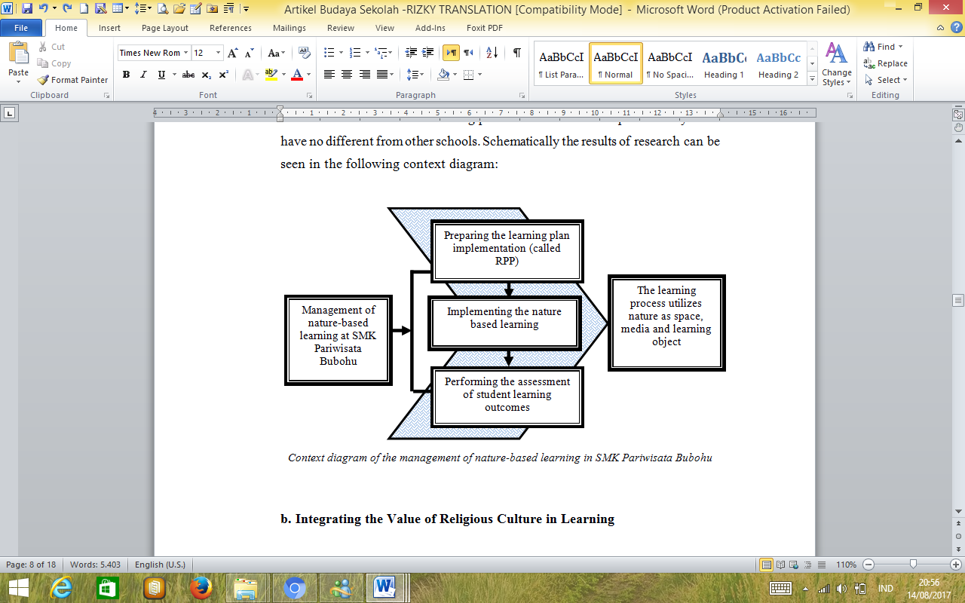

Figure 1. Context diagram of the management of the natural-based learning in Bubohu Private Vocational High School of Tourism

Context diagram obtained through the results of observation, interview and documentation study of all phenomena related to the management of natural-based learning in Bubohu. The results show that there are three stages of natural-based learning management at Bobuhu namely the stage of planning, implementation and assessment. At the learning planning stage, the teacher prepares the Learning Implementation Plan (LIP) containing the competency standard, basic competency, indicators, objectives, materials, methods, steps, developed life skill aspects, learning resources, media and assessment. The LIP developed by the teacher have not demonstrated the nature-based learning model applied.

At the implementation stage, teachers should use a natural-based learning model using nature as a place, media and learning resources. But the facts in school show that the teacher has not used natural-based learning model, thus giving less optimal impact in supporting the optimization of natural-based learning management.

In the assessment phase, the teacher develops a natural-based learning assessment that includes three things: observation, anecdotal notes, and fortofolio. This is in accordance with research conducted by Sabzian (2013) states that the teacher is one of the important foundation in conducting the assessment properly and correctly to improve student learning achievement. Therefore, various assessments with observers, anecdotal and fortofolio records need to be done thoroughly and completely.

## Integrating the value of religious culture in learning

The integration of the values of religious culture in learning appears in the beginning and in the end of learning activities, while core learning activities have not been integrated with religious cultural values except in the subjects of religious education. In the early activities of learning, students must pray a prayer led by one student. After the prayer is over, the teacher invites the students to jointly give thanks to The One Almighty God for all the blessings has been given. The culture of prayer teaches the students to always start the activity with prayer and thankfulness.

The same is done at the end of the lesson, where the students pray and give thanks as the lesson has been finished with the hope that it may be useful. Other findings indicate that in core learning activities, teachers do not integrate religious cultural values except on religious education subjects. This is done because on other subject matter there is no sub-competence and basic competence that can be integrated with the religious culture. In summary, it can be seen in the context of the diagram below:

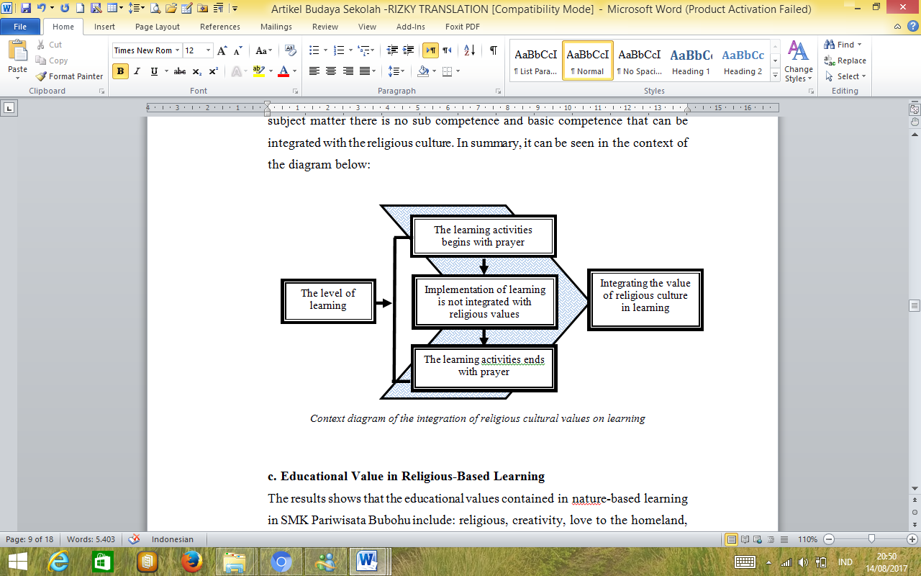

Figure 2. Context diagram of the integration of the religious cultural values on learning in Bubohu Private Vocational High School of Tourism.

The process of integrating the values of religious culture on learning in Bubohu on the early activities of learning is realized with a culture of prayer every time a new lesson begins. The habit of praying before beginning the lesson is taught to believe in God and always start the activity by praying and pleading to God.

In the core activities of learning, the value of religious culture appears on the subjects of Religious Education and the other subjects. But the process of material integration in the lessons with religious cultural values has not been able to form a religious person who is religious and diligent in performing worship according to his religion and belief. This is as a consequence of the implementation of learning that is not integrated with religious values.

The integration of religious cultural values in closing activities is indicated by praying together as done in the initial activity and continued with an expression of gratitude to God because the lesson has been completed.

## Educational value in religious-based learning

The result shows that the educational values contained in natural-based learning in Bubohu include: religious, creativity, patriotic, reading fondness, and environmental concern. In summary, the results of the study can be illustrated in the following conceptual diagram:

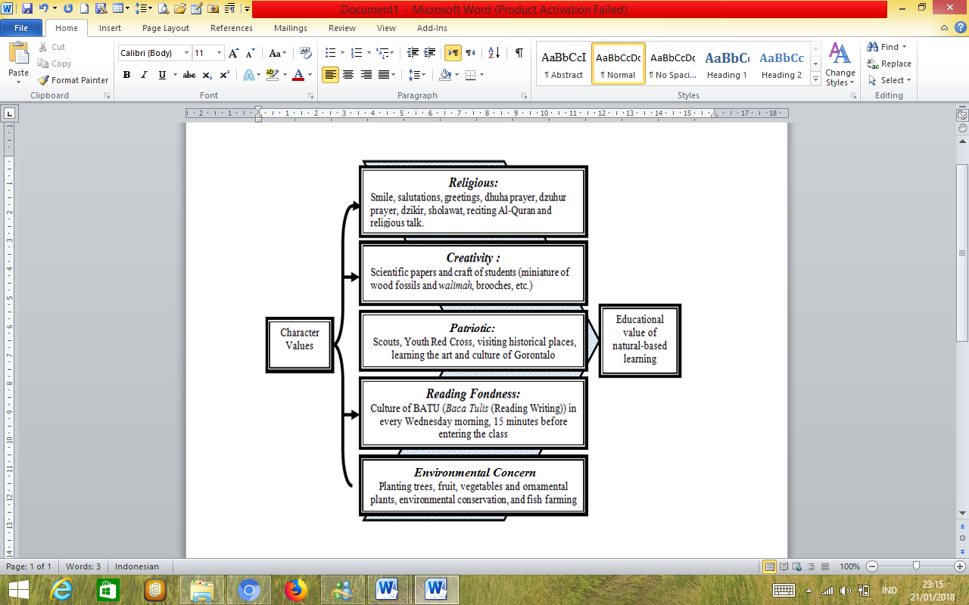

Figure 3. Educational value of the natural-based learning in Bubohu Private Vocational High School of Tourism.

First; religious, which is indicated by 3S culture (*Senyum* (smile), *Salam* (salutations), *Sapa* (greetings)), dhuha prayer in congregation culture in every Tuesday, dzuhur prayer in congregation every day, and reciting Al-Quran.

Second; creativity, is shown by activities that sharpen the creativity of students in writing scientific papers and craft making such as miniature souvenirs of wood fossil and miniatures of *walimah* (wedding event) which is a typical souvenir from Bubohu.

Third; patriotic that is shown by the activity of the students in extra-curricular activities such as Scouts, Youth Red Cross, visiting the historical sites in Gorontalo Province and the implementation of arts activities that introduce the students to various traditional arts such as saronde dance, tidi dance, longgo dance and craft of *karawo* (typical cloth of Gorontalo) to foster the love of the region and the country.

Fourth; reading fondness that is shown with the culture of BATU (*Baca Tulis* (reading writing)) which is held every Wednesday morning before the lesson begins.

Fifth; environmental concern demonstrated by preserving the environment, by planting and maintaining trees both inside the school and outside the school environment.

## Preservation of wood fossil museum as a learning resource

Observations and interviews on the preservation of the wood fossil museum as a source of learning are illustrated in the following conceptual diagram:

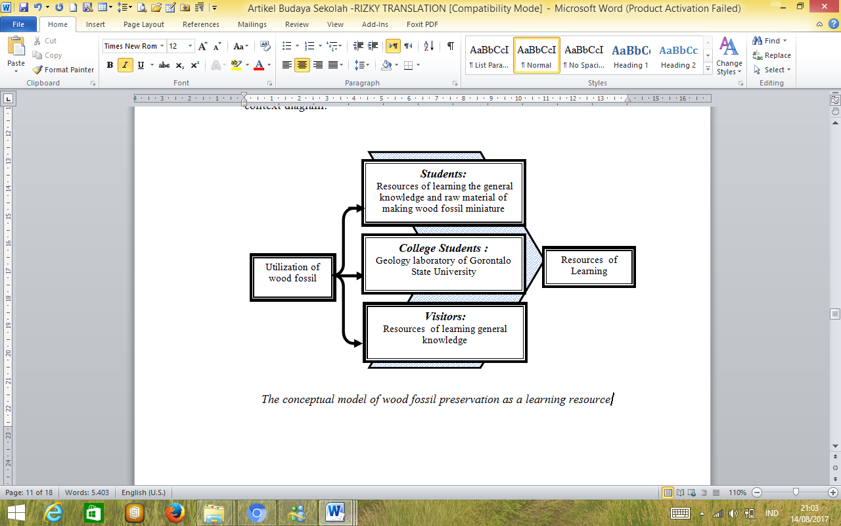

Figure 4. The conceptual model of the wood fossil preservation as a learning resource in Bubohu Vocational High School of Tourism.

Bubohu stores the largest wood fossil in the world, ranging from 5,000 (five thousand) fossils premises of about 1.8 million years according to the research results that be held by scientists from Japan.

Besides being an artifact containing historical value, the fossils in Bubohu are also used as learning resources by students and visitors to add information and their knowledge about wood fossil which is not found in many places. Students utilize the woodfossil not only as a learning resource for one particular subject but also as additional knowledge in general. Students are given information about wood fossil in order to provide an explanation if the visitors ask about the existence of wood fossil. Small wood fossil fragments are produced by the students to becomesome miniature souvenirs which are sold to visitors as a typical souvenir Bubohu.

Wood fossils are also a source of learning for visitors and other parties such as college students. The existence of this fossil is utilized by Gorontalo State University as alaboratory of Geology.

As for visitors, wood fossils are one source of learning for them. Any visitor who comes to school can request information about the existence of the wooden fossil.

# Discussion

## Management of the natural-based learning

Management of learning is one of the school authority as set forth in Law No. *32 Year 2004* regarding to *Regional autonomy dan Law No. 20 Year 2003* about the system of National Education (*Sistem Pendidikan Nasional*). In the law, it is defined in terms of the authority and responsibility of schools within the School-Based Management framework includes: (a) management of learning and teaching process; (b) planning and evaluation of school programs; (c) the management of the curriculum; (d) management of personnel; (e) the management of equipment and supplies; (f) management of financial; (g) student services; (h) relationship between the school and the community; and (i) the management of the school climate. This shows that the school has autonomy in terms of management of learning and teaching process. The learning and teaching process should be supported by learning tools including Learning Plan Implementation (*Rencana Pelaksanaan Pembelajaran*), Syllabus and Assessment of Student Learning Results.

This learning tool is an administrative obligation that must be prepared by the teachers as the basis of guidance in carrying out the learning activities. The learning implementation tools include some information about the standards of competency, basic competency, learning objectives, subject matter, learning methods, learning steps, instructional media, sources and techniques of assessment. With the RPP, syllabus and the assessment of student learning results, it can facilitate teachers in implementing learning.

The result shows that in the implementation plan of learning compiled by the teachers of subjects, it does not seem any natural-based learning. There is no difference between the implementation plan of learning in Bubohu with the other schools in general. This means that Bubohu has not developed a natural-based learning implementation plan. In the assessment of learning outcomes, assessment techniques used are also developed into natural-based assessment techniques. Although already using several types of assessment, the assessment remains very monotonous because the ability of teachers less than optimal.

The other result shows that in the assessment of student learning results techniques that have been used, it also are not developed into the natural-based assessment techniques. The assessment is so monotonous so that the natural-based learning activities are not accommodated in the assessment of student learning outcomes. The result of the research is supported by the evidence in the form of the learning plan of each teacher and the assessment format used for the assessment of student learning outcomes.

Other research results show that natural-based learning aims to bring the students closer to nature, to teach students to love the nature and to love the Creator of the universe. Another goal is to build a strong psychology, morals and mental entrepreneurship. Furthermore, the benefits of the natural-based learning are the students become very concerned with the environment and natural surroundings. The habit of learning with nature and the environment makes the students more grateful and closer to the Creator. It is seen from the learning point of view where the students are not bored and drowsy so they feel more comfortable. In addition, natural-based learning makes the emotional connection of the teachers and students are closer. This is supported by Bay research (2015) which concludes that learning outside the classroom with direct practice and conducting live experiments with a pleasant natural atmosphere will enhance the ability of positive and creative thinking of learners. This can be interpreted that learning in the open will make the students more creative.

The description of the research results is similar to the concept of the School-Based Management which gives the school a chance to provide better and more adequate education for the students (Ministry of Education and Culture, 2011: 12). With the existence of natural-based learning, the purpose of national education that is creating a generation of believers and cautious to The One Almighty God, who has the noble character, healthy, knowledgeable, capable, creative, independent, democratic and being responsible can be accommodated as a whole (DepartemenPendidikan Nasional, 2003).

Based on the above explanation, it can be concluded that the Bubohu implements natural-based learning by utilizing nature as a place, media and learning resources. Natural-based learning has a very positive impact because it provides an active, creative, innovative and fun learning environment.

## 5.2 The integration of religious cultural values in learning

The religious culture is one of the school culture developed in Bubohu. The religious culture which is developed by the school is the part of the concept of Bongo Village as a religious tourism village. The religious culture is developed for familiarizing the students with the positive things, so that the habits become the values and norms that will be able to be adopted by the member of the school. This is in line with the views of Masaong & Tilome (2011) and Wohlstetter & Mohrman, (1994) which states that school culture is: (1) the determinant of how energy and structures of the school are transformed into useful work; (2) the value of the school system that will affect on how the work is done and how the member behave; (3) constructed from the belief that held deeply about how schools should be managed or operated; (4) a system of meaning-sharing among the school members distinguishing one school from another.

The explanation above implies that the school culture built by Bubohu is a religious culture that is agreed and implemented by all member of the school. The religious culture is not just a slogan but as a value system of the school so that all the activities in the school become religious value. In addition, by embracing the religious culture, it gives a different color that distinguishes Bubohu with the other schools.

Bubohu is more integrate the value of religious culture on activities out of learning range wheter inside of school or outside.The integration of the religious cultural values is imperative, as Miftah and Ritandiyono (2008) argue that Indonesian society is a religious society that adheres to the values that exist in their religious teachings, reflected in their attitudes or behaviors and the circumstances of their life in general.

This opinion is in accordance with Article 29 Paragraph 1 of the *Undang-Undang Dasar 1945* which states that the state is based on the One Supreme God which is also contained in the first principle of the Indonesia principle namely Pancasila.

## 5.3 The educational value contained in the religious-based learning

The value of education is the positive values contained in natural-based learning. The results showed that there are many educational values contained in the natural-based learning in Bubohu include: 1) religious, which is indicated by 3S culture (*Senyum* (smile), *Salam* (salutations), *Sapa* (greetings)), and in the religious activities; 2) creativity, is shown by activities that sharpen the creativity of the students in writing scientific papers and craft making such as miniature souvenirs of wood fossil and miniatures of walimah (wedding event) which is a typical souvenir from Bubohu; 3) patriotic that is shown by the activity of the students in extra-curricular activities such as Scouts, Youth Red Cross, visiting the historical sites in Gorontalo Province and the implementation of the various arts activities; 4) reading fondness that is shown with the culture of BATU (*Baca Tulis* (reading writing)) which is held every Wednesday morning before the lesson begins; and 5) environmental concerns.

The results above show that the value of education in religious-culture-based learning developed in Bubohu adopted from the value of character education nation developed by Ministry of Education and Culture of Indonesia. The character education is intended to form a moral personality and noble character. This is in line with the opinion of Thomas Lickona (1991) who states that charactereducation is education to form the personality of a person through a moral education where the results can be seen in his actual actions include good behavior, responsible, respect for the rights of others, hardworker and etc.

Furthermore, according to the Ministry of National Education (center of curriculum), on the development of cultural education and character of the nation there are 18 (eighteen) national character values, but the education unit can determine the priority of development, so that Bubohu raised 5 (five) while they still integrating the value of other characters in learning.

Other research results show that the Bubohu as a nature school has been familiarizing the students to develop positive cultures so that the school not only produces students who has the intellectual intelligence but also have the spiritual and emotional intelligence.

## 5.4 The preservation of the wood fossil museum as learning source

Bubohu stores the largest wood fossil in the world, ranging from 5,000 (five thousand) fossils premises of about 1.8 million years according to the results of research of scientists from Japan. Besides being an artifact containing historical value, the fossils in Bubohu are also used as learning resources by students and visitors to add information and their knowledge about wooden fossils which is not found in many places.

The Students utilize the wood fossil musseum not only as a learning resource for one particular subject but also as additional knowledge in general. Students are given information about the wood fossil in order to provide an explanation if the visitors ask about the existence of wood fossil. The small wood fossil fragments is processed by the students to become some miniature souvenirs which are sold to visitors as a typical souvenir Bubohu.

The existence of this fossil is not only utilized by the students but also the visitors and by Gorontalo State University where they use the museum as a laboratorium of Geology to observe the wood fossil. This is in line with the concept of a nature school developed by Lendo Novo. In addition, the leader of the foundation was inspired by the life of Prophet Muhammad SAW whom learn things from nature. Through the support of the professional teachers and the availability of library books as the window of the world, the students are printed as a smart generation who have good morals and entrepreneur spirit.

# conclusions

Based on the results of the research and discussion, it can be concluded that the natural-based learning management in Bubohu Private Vocational High School of Tourism is using nature as a space, media and learning objects. The integration of religious cultural values in learning at this school appears in the beginning and in the end of learning activities. In the core of the learning activities, the teachers do not integrate the values of religious culture. The educative values contained in the natural-based learning at this school include: (1) religious, (2) creativity, (3) patriotic, (4) reading fondness, and (5) care about the environment. The wood fossil museum in this school is used as a source of learning and character development by students, collage students and visitors.

REFERENCES

Bay, Neslihan, Dondu. 2016. ” Outdoor in Preschool Teaching : A Model Implementation in Turkey *“*. *International of studies in Education.* Macrothink Institute, Vol. 6, Num. 1, February 2016,p.56-73.

Chatab, Nevizond. (2007). *Profil Budaya Organisasi,* Bandung: Alfabeta.

Chiarotto, Lorraine. (2011). *Natural curiosity:  A Resource for Teachers: Building Children's Understanding of The World through Environmental Inquiry*. Laboratory School at the Dr. Eric Jackman Institute of Child Study, Ontario Institute for Studies in Education, University of Toronto. Retrieved September, 23, 2017, from

https://www.naturalcuriosity.ca/aboutus.php?m=b.

Ministry of Education of Republic of Indonesia.(2003). *Law No. 20 Year of 2003*. Jakarta.

Ministry of Education of Republic of Indonesia. (2011). *Manajemen Peningkatan Mutu Berbasis Sekolah. Jakarta*: Direktoral PLP.

Undang-Undang Dasar Republik Indonesia. Jakarta: MPR. RI.

Lickona, Thomas.(1991). *Educating For Character: How Our Schools Can Teach Respect and Responsibility.* New York: The New York Times Company.

Masaong, Kadim & Tilome, Arfan. (2011). *Kepemimpinan Berbasis Multiple Intelligence*. Bandung: Alfabeta.

MacNeil, J., Angus, Prater, L., Doris and Busch, Steve. (2009) The Effects of School Culture and Climate on Student Achievement. International Journal of Leadership in Education, 12:1,73-84, DOI: 10.1080/13603120701576241. https://doi.org/10.1080/13603120701576241. Retrieved from <http://www.tandfonline.com/doi/pdf/10.1080/13603120701576241>.

Montgomery, A, Robert; Millenbah, F, Kelly. 2011. ” Examining Whether Learning Space Affects the Retention of Experiental Knowledge *“*. *Journal of Natural Resources and Life Sciences Education.* The American Society of Agronomy , Vol. 40, 2011.

Moradi, Saeid, Hussin, Bin., Sufean, and Barzegar, Nader. (2012). School-Based Management (SBM), Opportunity or Threat (Education systems of Iran). International Conference on Education and Educational Psychology (ICEEPSY 2012). Published by Elsevier Ltd. doi: 10.1016/j.sbspro.2012.12.179.

Neal, Richard G. (1991). *School Based Management: A Detailed Guide for Successful Implementation.* Retrieved from https://eric.ed.gov/?id=ED436833 on 21 December 2017.

Oppong, Steward H. (2013). *Religion and Identity*. American International Journal of Contemporary Research. IJCR, Vol. 3, pp. 11-14. Retrieved from <http://www.aijcrnet.com/journals/Vol_3_No_6_June_2013/2.pdf> on 22th December 2017

Organization for Economic Cooperation and Development. (2010). *The nature of learning. Using Research to Inspire Practice.* OECD Publications. Retrieved September, 23, 2017, from http://www.oecd.org/edu/ceri/50300814.pdf.

Priatna, Asep. (2016). *Improving the Quality of the Integrated Junior-High School of Lampang, Subang, West Java, in Achieving National Education Standards*. 6th International Conference on Educational, Management, Administration, Leadership (ICEMAL). Published by Atlantis Press.

S, Theodore; May. 2004.” Teaching in the Field: Working With Students in the Outdoor Classroom *“*. *The Journal of Environmental Education.* ProQuest,Vol. 35,Num. 4, 2004,p.67.

Sabzian, Fouzieh; Ismail, Zurida; Ismail,Mohamed,Abdulmalik, Shaik; Vajargah, Fathi,Kourosh . 2013.” An Evaluation of The Effectiveness of Teacher’ Professional Development (TPD) in Iran using Akker Spide Web Model *“*. *International Journal of Human Resoure Studies.* Macrothink Institute,Vol. 3,Num. 2, March 2013,p.1-12.

Stoll, Louise. (1998). *School Culture.* Reprinted from School Improvement Network's Bulletin, No. 9, Autumn 1998. Retrieved from http://www.educationalleaders.govt.nz/Culture/Understanding-school-cultures/School-culture on 21th December 2017.

*Vislocky, Karen.* (2005)*. The Relationship Between School Culture And Student Achievement In Middle Schools.* Electronic Theses and Dissertations. 631.<http://stars.library.ucf.edu/etd/631>.

Wardekker, Willem L. and Miedema, Siebren (2001). *Identify, Cultural Change, and Religious Education*. British Journal of Religious Education, 23: 2, 76-78. http://dx.doi.org/10.1080/0141620010230202.

Wohlstetter & Mohrman. (1994). *School-Based Management: Organizing for High Performance.* Foreword by Allan Odden*. San Fransisco: Jossey Bass Publishers.*