FACTORS AFFECTING READING INTEREST OF ELEMENTARY SCHOOL STUDENTS

Ali Mustadi
Elementary School Teacher Education Department
Yogyakarta State University
Yogyakarta, Indonesia
ali_mustadi@uny.ac.id

Faisal Amri
Elementary School Teacher Education Department
Yogyakarta State University
Yogyakarta, Indonesia
Faisalamri_10@yahoo.com

Abstract— The purpose of this research is to determine factors affecting reading interest of fifth graders. The study applied a qualitative survey research. The data were analyzed using factor analysis. The research population was 590 students. The research sample was 238 students. The results show internal factors namely (1) physical condition, understanding of content and reading needs, (2) reading and attitude skills, (3) vision and hearing, (4) learning motivation and school work needs, (5) psychic maturity, (6) understanding and achievement, (7) body condition and curiosity, (8) body structure and habits and external factors namely (1) imitating parents, teacher attention, following peers, (2) peer invitations, cultural situations, practicing religious teachings, (3) variations of readings from teachers, rules and readiness to get religious readings and commands, (4) readiness to get readings, (5) completeness of reading and religious teachings, (6) provision of readings and availability of reading places (7) peer pressure, culture and climate environment (8) encouragement and availability of readings, association with friends, (9) reading availability, (10) parental encouragement.

Keywords: interest in reading, elementary students

I INTRODUCTION

Reading is a window to the world; it means that all information from every corner of the world can be acknowledged by someone through reading. The reading activity itself cannot be done well without the readers' internal motivation. Reading interest will not come up, grow and change without human interaction with certain objects. Hera Lestari, et al (2009) explains that interest is an impulse within a person or a factor that causes selective interest or attention, which causes the selection of an object or activity that is beneficial, pleasant and over time will bring satisfaction within the person. While reading interest according to Darmono (2007: 214) is the desire to encourage someone to do something about reading. Interest in reading is performed by a strong desire
Reading interest is one of the keys to one's success in mastering science and technology. Interest develops into habit. In other words, interest will be a requirement to build a habit, if reading activities are based on high interest, the activity will be carried out constantly and regularly. But in fact, students' current interest in reading is low. The results of a research conducted by the Programme for International Student Assessment (PISA) quoted from the school literacy movement manual in elementary schools, organized by the Organization for Economic Cooperation and Development (OECD), illustrates that in two assessment period held in 2009 and 2012, Indonesian students ranked 64th and 65th out of all participating countries in mathematics, science and reading.
Interest is not inborn but it is obtained when there is an interaction with certain objects. Likewise, the development of children's reading interest is influenced by several factors. Reading interest will not come up, grow and change without human interaction with certain objects. This implies that interest is formed in relation to an object. Interest is basically the acceptance of a relationship between oneself and something outside them. The stronger or closer the relationship, the greater the interest. Purves and Beach (in Heri and Siti, 2013: 102) explains that
"Some factors are influenced by a reading interest, either in child self or out of child self. Personal factors are existing factors in the child's self, that is including age, sex, intelligence, reading abilities attitude and physiologic needs. While institutional factors are factors out of child self, that is including reading book number available and kind of book, social status, parent economic and ethnic background, then in the same age child friend, teacher and parent influences. "
So, from the opinion of Purves and Beach above, it is explained that reading interest is influenced by two factors, namely personal factors; factors from within the child's self, including age, sex, intelligence, reading ability, attitude and children psychological factors. Institutional factors, namely factors from outside the child's self, including type of book, social status, family economic condition, peers, teachers and parents' influence and many others.
According to Surya (2003: 37) there are several factors that affect someone's reading interest, namely factors from within (internal) which consists of: (a) Physical factors or individual physiology which is innate, such as vision, hearing, body structure, and so on. (b) Psychological factors, both innate and hereditary, consisting of: intellectual factors, consisting of potential factors, namely intelligence and talent, as well as actual factor or actual skills, namely achievement or accomplishment. Non-intellectual factors, namely certain personality components such as attitudes, habits, needs, motivation, self-concept, self-control, emotion, and so on. Maturity factors, both physical and psychological factors from external (external) including social factors, which consist of family environmental factors, cultural factors, such as customs, science, and so on. Physical environmental factors, such as home facilities, learning facilities, climate, etc., Spiritual factors and the religious environment. Moreover, Wahyuningsih, S., & Mustadi, A. (2019: 576) explained that the number of different reading titles on interesting topics can help learners to grow their interest in reading. The number of different reading titles on interesting topics can help students fostering their reading interest.
In conclusion, a student's interest in reading can be influenced by several factors both originating from within the child's self or internal factors or from outside the child's self or external factors. Internal factors consist of physical or physiological factors and psychological factors while the external factors consist of social factors, which consist of family environmental factors, cultural factors, physical environmental factors, spiritual factors and religious environments.

II. RESEARCH METHOD

A. Research Design
This study applied a qualitative survey research.

B. Place and Time of the Research
The study was conducted in the fifth grade of elementary schools in Pandak, Bantul District in the academic year 2018/2019, which is involving 18 schools from March 2016 to August 2019.

C. Population and Samples
The population of this study were all fifth-grade students of elementary schools in Pandak Subdistrict in the academic year 2018/2019, involving 590 students. This study used a proportional random sampling technique. Obtained a sample of 238 students. The samples were then divided proportionally for each elementary school.

D. Data Analysis Techniques
In analysing the factors, Singgih (2014: 59) explains that there are several processes that must be carried out, namely, determining what variables that will be analysed, testing the variables that have been determined, using the Bartlett test of sphericity method and MSA measurement (measure of sampling Adequacy). In initial stages of this factor analysis, screening of a number of variables was carried out, so that the variables that meet the requirements could be analysed. Factoring, this process would extract one or more factors from variables that had passed the previous variable test using the Principal Component method. If the result was doubted by the researcher, the rotation process could be done. Interpreting the formed factor, labelling the formed factor which is considered biased to represent the member variables of the factor. Validation, finding out whether the factor is valid or not.

III. RESEARCH RESULTS AND DISCUSSION

There were 8 internal factors and 10 external factors that influence students' interest in reading in grade V of elementary school students in Pandak District.

a. Description of KMO Test Analysis and Barlett's Test Results
The first thing to do is to analyse the feasibility of the data to be analysed using factor analysis by looking at the Barlett's Test of Sphericity, the Kaiser-Meyer-Olkin (KMO) test.
The following is a summary of the results of the SPSS output for the student internal factor questionnaire.
Table 1. KMO and Barlett's Test of Sphericity questionnaires
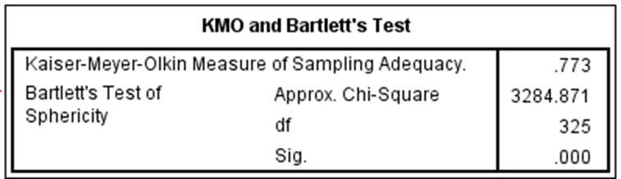

From the test results, the KMO value obtained is 0.773 on the student's internal factor questionnaire. While the value of Barlett's is at a significance level of 0,000 the KMO value of the student's internal aspect questionnaire exceeds 0.05. This means that it is feasible to do a factor analysis, then the MSA (Measures of Sampling Adequacy) testing would be conducted.
Table 2. Student MSA Internal Questionnaire scores
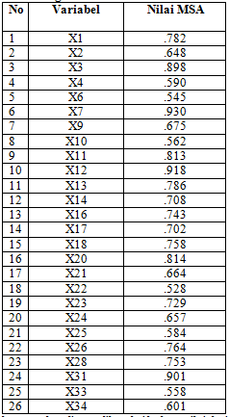

Based on MSA test data it is known that the value of each variable is greater than 0.5. Based on the results of the analysis, it can be seen that the variables in this study have an MSA value> 0.5, so that the next factor analysis can be done.
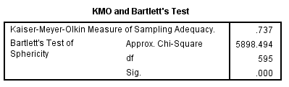
Table 3. KMO and Barlett's Test of Sphericity scores of Student Internal Questionnaire

The table above shows that the KMO value is obtained by 0.737 on the student's internal factor questionnaire. While the value of Barlett's is at a significance level of 0,000 the KMO value of the student's internal aspect questionnaire exceeds 0.05. This means that it is feasible to do a factor analysis, then at this stage, MSA results must also be seen.
Table 4. Student MSA external questionnaire scores.
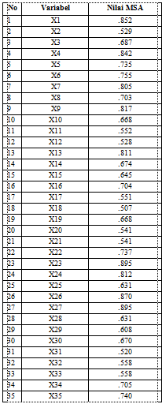

Based on the data above it is known that the value of each variable is greater than 0.5. Based on the results of the analysis, it can be seen that the variables in this study have an MSA value> 0.5, so that the next factor analysis can be done.

b. Description of the Results of Students' Communal Reading Interest
After the data is declared feasible for conducting factor analysis, the factor extraction process is then carried out by the main component method. The communal table in the appendix shows that in the internal factors column for variable X1, the extraction value is 0.638. This shows that about 63.8% of the variance of the X1 variable can be explained by the factors formed. Likewise, the extraction value on the external factor questionnaire value also shows the same result. At this stage, the communal value is between 0.0 to 1.0. The greater the communalities of a variable, the more closely related the factors formed.

c. Description of Eigenvalue Analysis Results of Students' Interest in Reading
The decision to make a number of factors is based on the sum of the eigenvalues of the correlation matrix between variables.
Table 5. The value of the Total Variance Explained of Student Internal Questionnaire
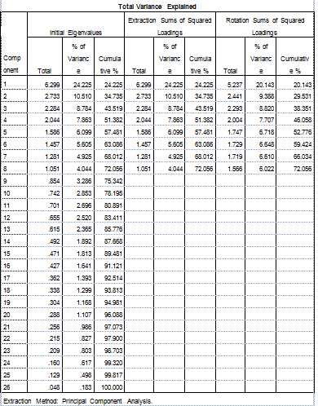

The results of the SPSS showed that the value of the Total Variance Explained in the internal factor questionnaire explained that from the 26 indicators analysed, it turned out that the results of computer extraction became 8 factors. Factor 1 is able to explain 24,225%; factor 2 is able to explain 10,510%; factor 3 can explain 8,784%; factor 4 is able to explain 7.863%; factor 5 is able to explain 6,099%; factor 6 is able to explain 5.605%; factor 7 is able to explain 4,925% and factor 8 is able to explain 4,044%. in other words, all the 8 factors are able to explain 72,056% (≥ 50%). Thus, the eight factors are feasible to be used to measure the variables.
The results of the SPSS showed that the value of the Total Variance Explained on an external factor questionnaire explained that from 35 indicators analysed the computer extracts them to be 10 factors.
Table 6. The Value of the Total Variance Explained of the Students’ Questionnaire
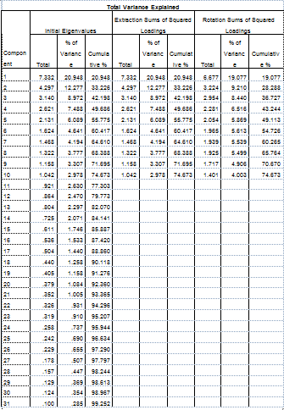
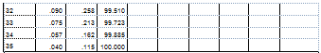

Factor 1 is able to explain 20,948%; factor 2 is able to explain 12,277%; factor 3 is able to explain 8,972%; factor 4 is able to explain 7,488%; factor 5 is able to explain 6,089%; factor 6 is able to explain 4,641%; factor 7 is able to explain 4,194%; factor 8 is able to explain 3,777%; factor 9 is able to explain 3,307% and factor 10 is able to explain 2,978%. In other words, the 10 factors are able to explain 74,673% (≥ 50%). Thus, the ten factors are feasible to be used to measure variables. To clarify the formation of factors that are formed from each questionnaire, we can take a look at the screen plot picture below.

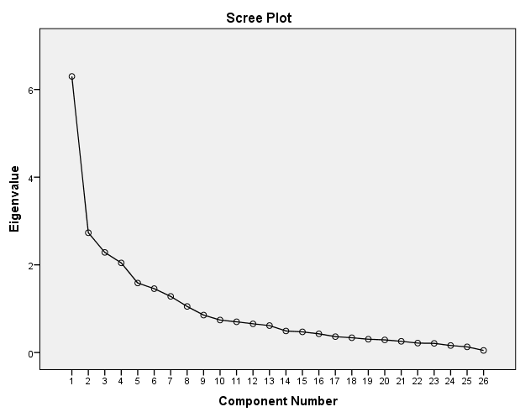

Figure 1. Screen Plot for Students’ Internal Factor Questionnaire
It can be seen in Figure 2.1 that the lines connected from the components 1,2,3,4,5,6,7 and 8 and the line decline and is above one, so that the components 9 to 26 are in the eigenvalent under one. This means that from 26 indicators or components there are 8 factors that can be formed.
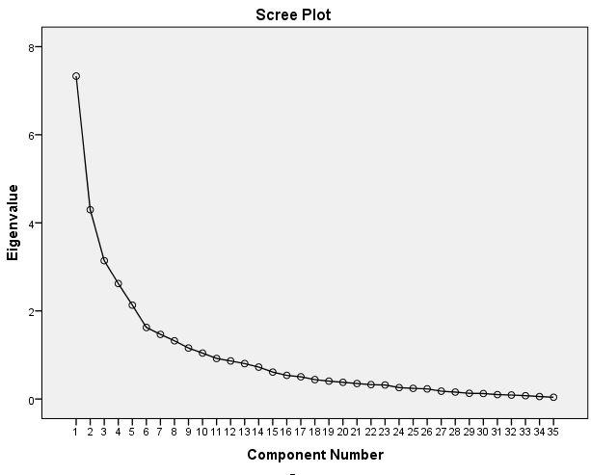

Figure 2. Student's External Factor Questionnaire Screen Plot
It can be seen in Figure 2 that the connected lines of the components 1,2,3,4,5,6,7,8,9 and 10 that the line declines and is above one, so that the components 11 to 35 are at the eigenvalent at under one. This means that from factors 31 indicators or components there are 10 factors that can be formed.

d. Descriptions of Student Reading Interest Rotation Analysis Results
The most important output in factor analysis is the factor matrix pattern. The factor matrix contains the coefficients used to express standardized variables expressed in complex factors. Factor rotation is done so that each factor has loading or non-zero coefficients. The rotation method used is the variamax rotation, which is a method that attempts to minimize the number of high loading variables on a factor, so that it will be easy to interpret. The results of the factor rotation on the student's reading interest questionnaire, by looking at the matrix component with rotated varimax, it is presented as follows.

Table 7. Variables Grouping
Variables Grouping
Factor | Internal | External
1 | X3, X7, X11, X12, X13, X16, X31 | X1, X4, X7, X9, X23, X24, X26, X27
2 | X17, X23, X24 | X10, X14, X15, X32
3 | X2 ,X4, X6, | X5, X13, X17, X34, X35
4 | X26 ,X28 | X21, X22, X25
5 | X33, X34 | X20, X33
6 | X14, X20 | X3, X19, X28
7 | X9, X21, X25 | X12, X16, X31
8 | X10, X22 | X6, X8, X11
9 | - | X18
10 | - | X2
Total | 24 | 33
By looking at the matrix component with varimax rotated, the rotation of the component matrix in the internal questionnaire can explain that the indicators clustered at factor 1 are X3, X7, X11, X12, X13, X16 and X31. The indicators that are clustered at factor 2 are X17, X23 and X24. Furthermore, the indicators that are clustered at factor 3 are X2, X4 and X6. In factor 4, the indicators are X26 and X 28. In factor 5, the indicators are X33 and X34. In factor 6 are X14 and X20. In factor 7 are X9, X21 and X25. In factor 8 are X10 and X22. Based on the results of the rotation factor, it turns out that indicators X1 and X18 do not exceed the 0.50 significance level, then indicators X1 and X18 are excluded. The grouping of variable indicators is then named according to the characteristics of the grouping factors.
The results of the rotation of the external questionnaire component matrix explained that the indicators that clustered in factor 1 are X1, X4, X7, X9, X23, X24, 26 and X27. In factor 2 are X10, X14, X15 and X32. Furthermore, in factor 3 are X5, X13, X17, X34 and X35. In factor 4 are X21, X22 and X 25. In factor 5 are X20 and X33. In factor 6 are X3, X19 and X28. In facto 7 are X12, X16 and X31. In factor 8 are X6, X8, and X11. In factor 9 the cluster is X18. In factor 10 is X2. Based on the results of the factor rotation it turns out that the indicators X29 and X30 do not exceed the significance limit of 0.50 then the indicators X29 and X30 are excluded. The grouping of variable indicators is then named according to the characteristics of the grouping factors.

1. Reliability Test
The following are the results of the analysis using SPSS in measuring the reliability of internal questionnaires.
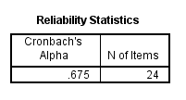
Table 8. Statistical Reliability for Internal Questionnaire

The table shows that the reliability value for the internal questionnaire has a value of 0.716. This is in accordance with what Toha, et al (2008) said in a study, a test can be accepted if the Cronbach Alpha coefficient of the instrument is greater than 0.60. Thus the 33 variables in the internal questionnaire are said to be reliable.
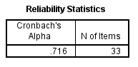
Table 4. Statistical Reliability for Internal Questionnaire

The table above shows that the reliability value for internal questionnaires has the number 0.716. This is in accordance with what Toha, et al (2008) said in a study, a test can be accepted if the Cronbach Alpha coefficient of the instrument is greater than 0.60. Thus 33 variables in the internal questionnaire are said to be reliable.

Discussion
1. Internal Factors Influencing Students' Reading Interest
Factors that affect students' interest in reading based on research results are caused by 8 factors. The first factor is named physical condition, understanding of content and the need to read. The naming of the factors is done according to the grouping variables. In the first factor the variables are X3, X7, X11, X12, X13, X16 and X31. Physical conditions, the level of understanding of content and the need to read are representations of the variables in group 1. This is consistent with the opinion that explains that someone's interest is influenced by several factors including individual physiology factors, intellectual factors in this case intelligence and non-intellectuals in this case, individual needs (Surya, 2003: 37).
The second factor is named the factor of reading ability and attitude. The naming of the factors is done according to the grouping variables. In the second, there are X17, X23 and X24. Ability and attitude are representations of this grouping variables. This is in accordance with Dwi Sunar Prasetyono (2008: 28) who explains that the factors affecting reading interest in children are due to internal factors, such as intelligence, age, gender, reading ability, attitude, and psychological needs.
The third factor is named the vision and hearing factor. The naming of the factors is done according to the grouping variables. In the third, there are X2, X4 and X6. Vision and hearing are a representation of the grouping variables. This is in accordance with the opinion that states that someone's interest is influenced by several factors from within themselves including individual physiology factors, intellectual factors in this case intelligence and non-intellectual in this case, individual needs (Surya, 2003: 37).
The fourth factor is named the factor of learning motivation and the need for schoolwork. The naming of the factors is done according to the grouping variables. In the fourth, the variables are X26 and X 28. Motivation of learning and the need for school work is a representation of the grouping variables. This is in accordance with the Surya’s (2003: 37) opinion that states that a child's interest is also influenced by non-intellectual factors, namely certain personality components such as attitudes, habits, needs, motivation, self-concept, self-control, emotional, and so on.
The fifth factor is named psychic maturity factor. The naming of the factors is done according to the grouping variables. In the fifth the variables are X33 and X34. Psychic maturity is a representation of this grouping variables. Psychic maturity can be in the form of maturity in thinking. This is in accordance with Surya’s (2003: 37) who states that someone's interest is influenced by both physical and psychological maturity.
The sixth factor is named the understanding and achievement factor. The naming of the factors is done according to the grouping variables. In the sixth, there are X14 and X20. understanding and achievement is a representation of the grouping variables. This is in accordance with Surya, (2003: 37) who states that someone's interest is influenced by intellectual factors, which consist of potential factors, namely intelligence and talent, as well as actual or skill factors real, that is achievement.
The seventh factor is named the body condition factor and curiosity. The naming of the factors is done according to the grouping variables. In the seventh, the variables are X9, X21 and X25. Body condition and curiosity are representations of the grouping variables. This is in accordance with the opinion that states that someone's interest is influenced by several factors from within themselves, including individual physiology and psychology (Surya, 2003: 37).
The eighth factor is named the body structure factor and habits. The naming of the factors is done according to the grouping variables. In the eighth factor, the variables are X10 and X22. Body structure and habits are representations of grouping variables. This is consistent with the opinion which states that someone's interest is influenced by several factors from within among other factors, individual physiology and psychology in this case non-intellectual factors (Surya, 2003: 37).

2. External factors Influencing Students’ Reading Interest
There are 10 factors influencing students' interest in reading based on research. The first factor is named after imitating parents, teacher attention, following peers, availability of readings. The naming of factors is done according to the grouping variables. In the first factor, the variables are X1, X4, X7, X9, X23, X24, 26 and X27. This is consistent with the opinion of Hurlock (1978: 118-119) which explains that in general, interest grows among other things because of identification with others. Children take gears of the interests of others or people they admire and care about and also their behaviour patterns.
The second factor is named the factor of peer invitation, cultural situation, practice of religious teachings. The naming of factors is done according to the grouping variables. In second factor, the variables are X10, X14, X15 and X32. Peer invitation, cultural situation, practice of religious teachings are representations of the grouping variables. This is in accordance with the opinion of Surya, (2003: 37) which states that someone's interest is influenced by social, cultural, environmental and spiritual factors.
The third factor is named the variation factor of reading from the teacher, the rules and the ease of getting readings at home and religious orders. The naming of factors is done according to the grouping variables. In the third factor, there are X5, X13, X17, X34 and X35. Variations in reading from teachers, rules, the ease of getting readings at home and religious orders are representations of the grouping variables. This is consistent with what is described by Purves and Beach (in Heri Hidayat and Siti Aisah, 2013: 102) that reading is influenced by two factors, namely personal factors, factors that originate from within the child itself, including age, gender, intelligence, reading ability, attitude and psychological factors of children. Institutional factors, factors originating from outside the child's self, include: type of book, social status, family economy, peers, influence of teachers and parents and others.
The fourth factor is named the ease of getting read factor. The naming of factors is done according to the grouping variables. In the fourth factor, the variables are X21, X22 and X 25. The ease of getting a reading is a representation of the grouping variables. This is in accordance with the opinion of Crow and Crow (Rahman, 2004: 264-265) which explains that someone's interest is influenced by one of the factors outside the environment (environmental conditions), including (a) the environment around the school, such as: the state of the school building environment, also education and organizational systems and school administration (b) the environment around students' homes, such as neighbours, public facilities or facilities, social status, social situations, cultural situations, and so on.
The fifth factor is named the completeness factor of the type of reading and religious teachings. The naming of the factors is done according to the grouping variables. In fifth factor, the variables are X20 and X33. The completeness of the types of readings and religious teachings is a representation of the grouping variables. This is in accordance with the opinion of Mohamad Surya, (2003: 37) which states that someone's interest is influenced by social, cultural, environmental and spiritual factors.
The sixth factor is named the factor of parents providing readings and the availability of reading places. The naming of the factors is done according to the grouping variables. In the sixth factor, the variables are X3, X19 and X28. This is consistent with what was explained by Purves and Beach (in Heri Hidayat and Siti Aisah, 2013: 102) that the interest in reading is influenced by two factors, namely personal factors; factors that originate from within the child itself, including age, gender, intelligence, reading ability, attitude and psychological factors of children. Institutional factors; factors that originate outside the child's self, include: type of book, social status, family economy, peers, influence of teachers and parents and others.
The seventh factor is named peer pressure, culture and climate. The naming of the factors is done according to the grouping variables. In the seventh factor, there are X12, X16 and X31. Peer pressure, culture and climatic environment are representations of the grouping variables. This is in accordance with what was described by Purves and Beach (in Heri Hidayat and Siti Aisah, 2013: 102) that the interest in reading is influenced by two factors, namely personal factors; factors that originate from within the child itself, including age, gender, intelligence, reading ability, attitude and psychological factors of children. Institutional factors; factors that originate outside the child's self, include: type of book, social status, family economy, peers, influence of teachers and parents and others.
The eighth factor is named the encouragement factor and the availability of readings from the teacher, the intensity of association with peers. The naming of the factors is done according to the grouping variables. In the eighth factor, there are X6, X8, and X11. This is in accordance with what is described by Purves and Beach (in Heri Hidayat and Siti Aisah, 2013: 102) that the interest in reading is influenced by two factors, namely personal factors; factors that originate from within the child itself, including age, gender, intelligence, reading ability, attitude and psychological factors of children. Institutional factors; factors that originate outside the child's self, include: type of book, social status, family economy, peers, influence of teachers and parents and others.
The ninth factor is named the factor of the availability of readings at home. The naming of the factors is done according to the grouping variables. In the ninth factor, there is X18. The availability of readings at home is a representation of the grouping variables. This is consistent with the opinion of Mohamad Surya (2003: 37) which explains that a child's interest is also influenced by physical environmental factors, such as home facilities, climate learning facilities and so on.
The tenth factor is named the parent's encouragement factor. The naming of the factors is done according to the grouping variables. In the tenth factor, there is X2. Parental encouragement is a representation of the variables that cluster these. This is consistent with the opinion of Gottfried, Fleming, & Gottfried (in Carol K. Sigelman & Elizabeth A. Rider, 2009: 209-210) explains that parents can provide a cognitively stimulating home environment. This includes reading material in the home, engaging in intellectual discussions, attending lectures or cultural events, visiting museums, and holding high expectations for children’s education. By doing these things, parents stimulate intellectual curiosity and a desire to learn. Children who are successful and supported in a positive manner are likely to enjoy new challenges and feel confident about mastering them”

CONCLUSION
The factors that influence the reading interest of fifth grade of elementary students in Pandak sub-district are as follows: There are eight internal factors, namely (1) physical condition, understanding of content and reading needs, (2) reading and attitude skills, (3) vision and hearing, (4) learning motivation and school work needs, (5) psychic maturity, (6) understanding and achievement, (7) body condition and curiosity, (8) body structure and habits. There are ten external factors namely (1) imitating parents, teacher attention, following peers, (2) peer invitations, cultural situations, practicing religious teachings, (3) variations of readings from teachers, rules and readiness to get religious readings and commands, (4) readiness to get readings, (5) completeness of reading and religious teachings, (6) provision of readings and availability of reading places (7) peer pressure, culture and climate environment (8) encouragement and availability of readings, association with friends, (9) reading availability, (10) parental encouragement.

References

- Ahmad Susanto. (2015). Teori Belajar & Pembelajaran di Sekolah Dasar. Jakarta: Kencana
- J Carol K. Sigelman & Elizabeth A. Rider. (2009). Life-Span Human, Sixth Edition Development. Carolina: Wadsworth Cengage Learning
- Darmono. (2007). Perpustakaan Sekolah. Jakarta: Gramedia
- Hidayat, Heri, and Siti Aisah. "Read interest co-relational with student study performance in IPS subject grade IV (four) in state elementary school 1 Pagerwangi Lembang." International Journal of Scientific & Technology Research 2.1 (2013): 101-114.
- Hurlock Elizabeth B. (1978). Perkembangan Anak Jilid 2 (Alih Bahasa: Med. Meitasari Tjandrasa). Jakarta: Erlangga.
- Kemendikbud. (2016). Panduan Gerakan Literasi Sekolah di Sekolah Dasar. Jakarta: Direktorat Jendral Pendidikan Dasar dan Menengah Kementerian Pendidikan dan Kebudayaan. Diunduh pada tanggal 4 April 2016 dari http://dikdas.kemdikbud.go.id/wp-content/uploads/2016/04/Panduan-Gerakan-Literasi-Sekolah-di-SD.pdf
- Mohamad Surya. 2003. Bimbingan dan Penyuluhan di Sekolah. Bandung: CV. Aneka Ilmu
- Rahman, at all. (2006). Peran Strategis Kapala Sekolah dalam Meningkatkan Mutu Pendidikan. Jatinangor: Alqaprint.
- Singgih Santoso. (2014). Statistik Multivariat. Jakarta: PT Elex Media Komputindo
- Wahyuningsih, S., & Mustadi, A. (2019). The Implementation of Gerakan Literasi Sekolah (Gls) Program in Elementary School. KnE Social Sciences, 568-580. https://doi.org/10.18502/kss.v3i17.468

