Classroom Wall Color Selection at Public Elementary School in Salatiga

Ariza Chrisananda Nurendra
Post Graduate Program, Educational Technology
Yogyakarta State University
Yogyakarta, Indonesia
ariza.nurendra@gmail.com
Christina Ismaniati
Curriculum and Educational Technology, Faculty of Education Science
Yogyakarta State University
Yogyakarta, Indonesia
Ismaniati_fipuny@gmail.com

Abstract
Indonesian elementary students spent 7-8 hours learning in schools. Mostly, they spent their time inside the classroom do their activities. Learning process needs ideal condition. This condition provides an atmosphere that makes learners feel comfortable and happy to follow the teaching and learning process. Conditions where students can learn comfortably and happily. Learning in inevitably related to the environment. The intended environment is the class and social conditions (interaction) when the learning process happen. Classes have structures that can be manipulated to give students learning facilities in the classroom, namely the color of the wall. Wall’s color can be simulated according to the condition of the students. Color has effect on visual and psychology for students. This article uses quantitative method by questionnaire and involved 441 elementary students and categorize into two categories; lower classes (grade 1-3) and higher class (grade 4-6). The purpose of this article is to provide an overview of color that suit to the wall and can be applied to public schools in Salatiga.

Keywords: wall color, classroom, environment, elementary school

Introduction (Heading 1)
Students in elementary schools in Indonesia spend around 8 hours in school studying and most of them are spent in the classroom. Most interactions occur in the classroom (the process of learning and interaction with friends and teachers). Classroom is a place for children to find and gain knowledge and expertise that will help them later to become good individuals and ready to live their lives. In this case the physical environment in the classroom acts as a silent curriculum, which has the understanding that class design can simplify and enhance the learning process such as an open curriculum [1]. The visual environment can affect students' ability to feel visual stimuli and affect mentally. There are several factors about environment, they are 1) Ambience factor; temperature, noise, smell, music and lighting, 2) Design Factor; architecture, color, material, interior, texture, and room layout, 3) Social factor; ages, gender, customer, and personnel [2].
In addition, children have different need in classroom than adult. Children needs environment that help them feel convenient to study in the classroom. There are things must be considered in designing the class, including lighting, room acoustics, air quality, access, temperature, and class settings. Conventional class structures do not support children to interact with one another but only focus on completing their personal tasks [3]. One of the easiest and often the center of attention is the physical form of the class itself, namely the color of the classroom walls. In designing the classroom, there must be several considerations including considerations regarding: Nature; light, sound, temperature, air quality, relationship with nature, individualization; ownership, flexibility, and connection, stimulation; complexity and color [4]. Color in educational context can be divided into personal preferences and functional learning processes.
Color is an impression obtained by the eye from light reflected by objects affected by the light. Color is also an element that is able to give an impression on the eye towards a form that is psychologically capable of influencing feelings. This is also in accordance with the opinion that colors can affect human emotions and describe moods [5]. Color has a role in helping channel perceptions of an object. Color differences can increase differences in motivation which can later affect performance on cognitive tasks [6]. Color with positive associations can lead to increased motivation and color with negative associations can increase motivation aversion [7]. Color also affects the emotions and physiology that causes mood swings that also affect their performance [8]. Furthermore, color also influences human life physically, psychologically, and socially [9].
Colors based on their nature can be divided into two types, namely warm colors and cold colors. The warm color group is the red / orange family that has the nature and influence of warm, fresh, fun, stimulating, and passionate. Cold color groups including those from the blue / green family that have quiet, calm, darker and older properties, the colors are getting sinking and depressed [10] . The nature of color also has an influence on individual behavior. Hot colors stimulate children, simple primitive people, and are extroverted. Cold colors are calm, introverted, mature, and mature [11].

METHOD
This research is quantitative research. Data obtained using questionnaires distributed in four public elementary schools in Salatiga. The subject of this study consisted of students from grade 1 to class 6 students. The discussion will be divided into 2 parts, namely small classes and large classes. The number of students involved in this study amounted to 441 which was divided into 235 small class students and 206 large class students. Students are asked to sort the color choices of their favorite class. There are 7 choices of class wall colors that are selected in the questionnaire.
Picture 1. Red Wall Classroom Design
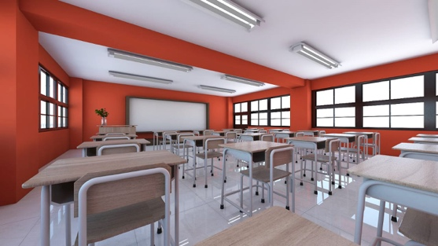

Picture 2. Purple Wall Classroom Design
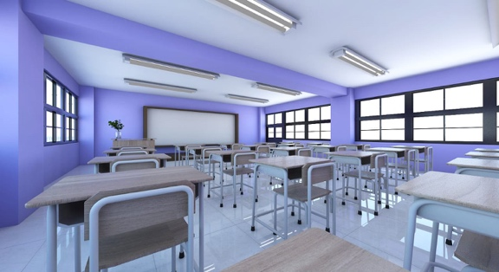

Picture 3. Yellow Wall Classroom Design
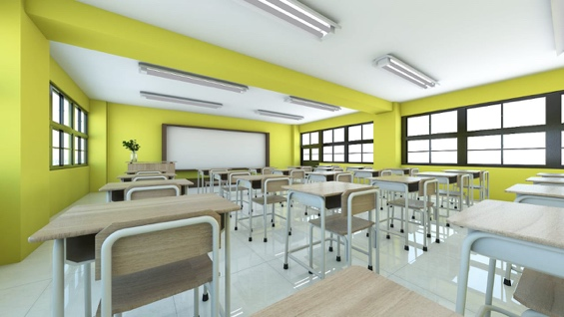

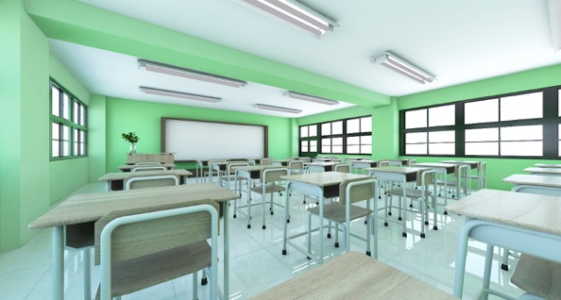
Picture 4. Light Green Wall Classroom Design

Picture 5. Orange Wall Classroom Design
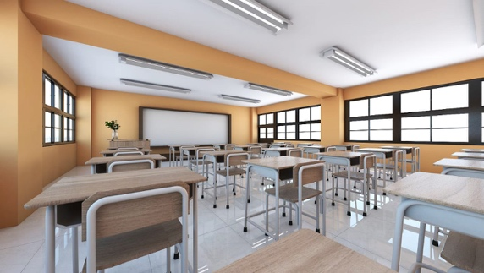

Picture 6. Light Blue Wall Classroom Design
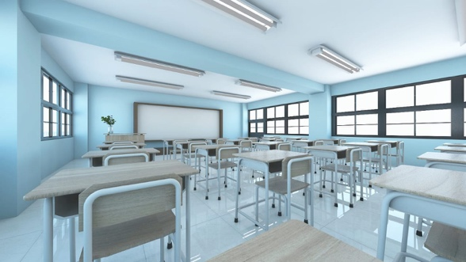

Picture 7. Beige Wall Classroom Design
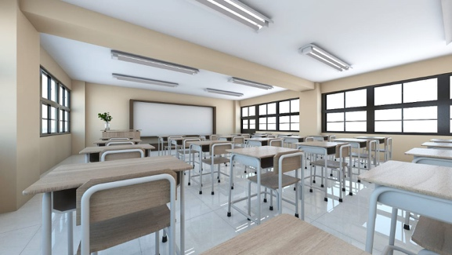

RESULT AND DISCUSSION
The class color selection questionnaire that has been distributed to 441 students related to their preferences regarding the color of the classroom walls gives the following results:

Result

Graph 1. Rank 1 Lower Class Color Preference

Graph 2. Rank 7 Lower Class Color Preference

Graph 3. Rank 1 Higher Class Color Preference

Graph 4. Rank 7 Higher Class Color Preference

Discussion
The application of color to the classroom wall must be in accordance with the characteristics of the child. The colors will be channeled through the eyes and can affect feelings, mental clarity, and energy levels. Based on his age, small children prefer bright colors [12] and also warm colors are recommended for small children [13]. In addition, the colors suggested for the school to give the impression of warm and bright are soft yellow (K.9 / 4), coral color (M.8 / 4), peach color (J.8 / 4) [14].This is also reinforced by [15] which states that the colors suitable for class are bright yellow-orange, cream, pale green, green, and blue-green. More active children will prefer cool colors and children who passively prefer warm colors [16].
From the results of these studies we can find out that for small classes (classes 1 to 3) the favorite color for their class walls is the color of the purple wall. The purple color was chosen by as many as 68 students or 29% of the total small class students 235 students. This shows that low-class students also like cold colors, namely purple. Meanwhile, the first color choice for class walls for large classes is light blue. Light blue color was chosen by 71 students or 35% of the total large class students namely 206 students. This is in accordance with the opinion of some experts who state that large class students will prefer cold colors to warm colors. On the other hand, related to the color that is the last or 7th is beige. There are similarities in the results of research in small and large classes. The beige color is the color that is the least chosen by students with 98 students or 42% of the total students as many as 235 students while for the large class there are 103 students or 50% students from a total of 206 students.
As quoted in Gale [17] children, especially young children, are interested and like warm and bright colors. As we age, color preferences change from pastel colors (elementary school) to bright cold colors like green, blue, and blue-green (middle school) to darker colors (middle school) such as burgundy, gray-gray, navy blue, dark green, and purple.
Color in the context of education, the choice can be seen in terms of personal preferences (preferences) or functional learning perspectives. In terms of preference, children prefer bright colors [18]. In addition, Eillen [19] the environmental needs between children and adults are different, children need a creative environment that later makes them comfortable in that environment. Children's needs in space are gaining a sense of freedom, safety, excitement, comfort and warmth.

CONCLUSION
The choice of wall classroom colors in order to help children feel safe and comfortable does require a lot of consideration. Within the educational technology area itself also provides an opportunity to develop this. This is supported by the understanding of 2008 learning technology, namely the study and ethical practice of facilitating learning and improving performance through creating, using, and managing appropriate technological processes and resources [20]. Likewise, with the understanding of 1994 learning technology, namely theory and practice of designing, developing, utilizing, managing, and evaluating processes and sources for learning [21].

When compared with the results of the researcher's research, there will be differences in the colors chosen by low-grade students. It turns out that purple is the favorite color of low-class students even though purple is a cool color. Meanwhile, beige colors that are warm colors are not a favorite choice of all students, both low and high class. There is still a need for further research related to the color of the classroom walls. Is the color to be used or chosen is the color that the child likes or the child fits in theory.

Acknowledgment
Thank you for all student and school; SDN Mangunsari 3, SDN Dukuh 3, SDN Mangunsari 4 and SDN Kalicacing 2 in Kecamatan Sidomukti, Salatiga for the cooperation.

References

- Taylor, A. P., & Enggass, K. (2009). Linking architecture and education : sustainable design for learning environments. University of New Mexico Press.
- Baker, J., & Cameron, M. (1996). The effects of the service environment on affect and consumer perception of waiting time: An integrative review and research propositions. Journal of the Academy of Marketing.
- Grubaugh, S., & Houston, R. (1990). Establishing a Classroom Environment That Promotes Interaction and Improved Student Behavior. The Clearing House: A Journal of Educational Strategies, Issues and Ideas, 63(8), 375–378. https://doi.org/10.1080/00098655.1990.10114133
- Barrett, P., Zhang, Y., Davies, D. F., & Barrett, D. L. (2015). Clever Classrooms. Diambil dari http://www.salford.ac.uk/cleverclassrooms/1503-Salford-Uni-Report-DIGITAL.pdf
- Darmaprawira, S. (2002). Warna : teori dan kreativitas penggunaannya (2 ed.). Bandung: ITB. Diambil dari http://library.uny.ac.id/sirkulasi/index.php?p=show_detail&id=7899&keywords=
- Mehta, R. & Zhu, R. (2009). Blue or red? Exploring the effect of color on cognitive task performances. Science, 323, 1226-1229.
- Elliot, A. J., Maier, M. A., Moller, A. C., Friedman, R., & Meinhardt, J. (2007). Color and psychological functioning: The effect of red on performance attainment. Journal of Experimental Psychology: General, 136(1), 154–168. https://doi.org/10.1037/0096-3445.136.1.154
- Küller, R., Mikellides, B., & Janssens, J. (2009). Color, arousal, and performance - A comparison of three experiments. Color Research and Application, 34(2), 141–152. https://doi.org/10.1002/col.20476
- Jalil, N. A., Yunus, R. M., & Said, N. S. (2012). Environmental Colour Impact upon Human Behaviour: A Review. Procedia - Social and Behavioral Sciences, 35(December 2011), 54–62. https://doi.org/10.1016/j.sbspro.2012.02.062
- Darmaprawira, S. (2002). Warna : teori dan kreativitas penggunaannya (2 ed.). Bandung: ITB. Diambil dari http://library.uny.ac.id/sirkulasi/index.php?p=show_detail&id=7899&keywords=
- Darmaprawira, S. (2002). Warna : teori dan kreativitas penggunaannya (2 ed.). Bandung: ITB. Diambil dari http://library.uny.ac.id/sirkulasi/index.php?p=show_detail&id=7899&keywords=
- Engelbrecht, K. (2003). The Impact of Color on Learning. NeoCon Perkins & Will, 1–5.
- Pile, J. F. (2009). A history of interior design (3 ed.). John Wiley & Sons.
- Darmaprawira, S. (2002). Warna : teori dan kreativitas penggunaannya (2 ed.). Bandung: ITB. Diambil dari http://library.uny.ac.id/sirkulasi/index.php?p=show_detail&id=7899&keywords=
- Nuhfer, E. B. (n.d.). Some Aspects of an Ideal Classroom: Color, Carpet, Light and Furniture. Diambil 3 September 2018, dari http://profcamp.tripod.com/ClassroomDesign/IdealClass.html
- Gaines, K. S., & Curry, Z. D. (2011). The Inclusive Classroom : The Effects of Color on Learning and Behavior. Journal of Family & Consumer Sciences Education, 29(1), 46–57.
- Daggett, W. R. (2008). Color in an Optimum Learning Environment International Center for Leadership in Education International Center for Leadership in Education, (March), 1–9.
- Barrett, P. (2010). Creating Sensory-sensitive Creative Spaces. Colour and Light in Architecture: First International Conference 2010 Proceedings, 187–192.
- Sari, S. M. (2004). Peran Warna Interior Terhadap Perkembangan. Dimensi Interior, 2(1), 22–36. https://doi.org/10.9744/interior.2.1.pp. 22-36.
- Januszewski, A., Molenda, M., & Association for Educational Communications and Technology. (2008). Educational technology : a definition with commentary. Lawrence Erlbaum Associates.
- Seels, B. B., & Richey, R. C. (2012). Instructional Technology : the Definition and Domains of the Field. Information Age Publishing.

