EARLY CHILDHOOD CURRICULUM MANAGEMENT IN AISYIYAH BUSTANUL ATHFAL GAMPLONG KINDERGANTEN

Restu Dwi Puji Astuti
Educational Management, Graduate School
Yogyakarta State University
Yogyakarta, Indonesia
Restudwip12@gmail.com
Zainal Arifin
Educational Management, Graduate School
Yogyakarta State University
Yogyakarta, Indonesia
Zainal_arifin@uny.ac.id

Abstract— This study aims to describe the implementation of early childhood education management curriculum in Aisyah Bustanul Athfal (ABA) Gamplong kindergarten. This study uses a qualitative research approach that is analyzed using descriptive analysis. The study was conducted by interviewing, observing and study documenting of 3 people namely the school principal, teacher and administrative officer at ABA Gamplong kindergarten. The results showed: (1) curriculum management in ABA Gamplong kindergarten including planning, organizing, implementing, and evaluating; (2) the obstacles that occur in ABA Gamplong kindergarten are the teachers feel overwhelmed in dealing with children who are very active so they are not focused. To overcome this the teacher must have skills in handling children while in class.
Keywords—Curriculum Management; early chilhood education

Introduction
The development of the age of the 21st century is very rapid with the presence of the industrial revolution 4.0. This has an impact on the demands of human resources to respond to the challenges given. The quality of human resources in Indonesia is ranked 87 out of 157 countries [1] Education is important to improve the quality of human resources. Education occupies a central position in development because it is very closely related to improving the quality of human resources. Today's society is very dynamic requiring an important curriculum to be considered, because the curriculum is one of the important instruments in the education process.
The curriculum has a central position in the education process because the curriculum directs all forms of educational activities with the aim of enabling the achievement of educational goals. The curriculum as an education program that is well organized and developed will produce students who adhere to the national process, meaning that without a good and appropriate curriculum it will be difficult to achieve the goals and objectives of education that aspires. For the curriculum to be managed effectively and efficiently, the curriculum must adhere to the principles of curriculum management. Curriculum management is the main management substance in schools.
Curriculum and learning, are two things that can’t be separated. As a plan or program, the curriculum will not be meaningful if it is not implemented in the form of learning. And vice versa, without a curriculum or plan, there can be no effective instruction and without instruction the curriculums has little meaning.[2]
One of the keys to the success of kindergarten management is the success in implementing the curriculum in accordance with educational goals. This is in accordance with the opinion from the Head of the West Java Education Office who said that, the most important thing is how to prepare human resources who are not only smart but have a character meaning other than them with good technology and intelligence, but their character in terms of culture, in terms of protecting the environment, from religion, it becomes important.[3]
Clear and systematic curriculum management certainly must be highly considered in early childhood education, because they must always pay attention to the level of development and psychology of students. Because every child is unique, in the sense of patterns and times of development, both personality, learning styles and family background. The curriculum and interactions of adult children should be tailored to each individual.
The management curriculum for early childhood education is different from other school level curriculum management such as elementary school, junior high school, or high school. Because early childhood in the range of 0-6 years, is a child who is in need of educational efforts to achieve the optimization of all aspects of both physical and psychological development that includes intellectual, language, motoric, and social emotional development. At this time also occurs the maturation of physical and psychological functions that are ready to respond to the stimulation provided by the environment.[4]
The basic principle of curriculum management is to try to let the learning process run smoothly, with benchmarks for achieving goals by students encouraging teachers to develop and continuously improve learning strategies.[5] This was reinforced by Katuuk who suggested that the availability of documents and instruments was the main foundation in implementing the 2013 curriculum implementation strategy in the field in order to achieve the expected quality. In addition, monitoring and evaluation needs to be done so that the participation of all parties can be strengthened and to realize better management and implementation strategies.[6]
Successful implementation of the curriculum requires good management. In implementing the 2013 curriculum, there are several important management aspects as a strategy to strengthen its implementation. These aspects include planning, organizing, implementing, and evaluating.
This research is relevant to the research “Management school curriculum of inclusion in the Kindergarten the talents of Semarang”.[7] The results of the study are more or less the same, namely curriculum management in Kindergarten the talents of Semarang including planning, implementation and evaluation. What distinguishes is the existence of children who need talent so as to provide special individual programs, whereas in this study there are no children with special needs but in the curriculum inserted Islamic religious material.
The question in this research is how is curriculum management in ABA Gamplong Kinderganten and what are the obstacles and solutions related to curriculum management in ABA Gamplong Kindergarten?

METHOD
This research is a descriptive qualitative research, because researchers want to dig up information-information about curriculum management in kindergarten. The subjects in this study amounted to three people namely the principal, teacher, and administrative officer of ABA Gamplong Kindergarten which is located at Gamplong, Sumberrahayu, Moyudan, Sleman, Yogyakarta.
Data collection techniques used in this study were interviews, observation and study documentation. The instruments used in this study were interview guidelines, observation guidelines, and study documentation guidelines. To check the validity of the data, researchers used data triangulation which was done through checking data from other parties as a comparison. Then the data analysis technique in this study uses interactive model data analysis techniques from Miles & Huberman including data collection, data reduction, data display, conclusion drawing/verivication.[8] The steps of the analysis are as shown below.
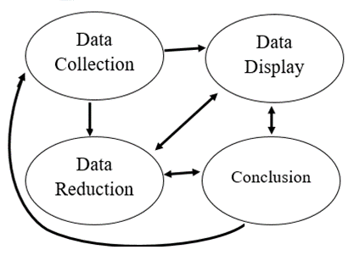
Fig 1. Interactive analysis model Miles and Huberman

RESULT AND DISCUSSIONS

Curriculum management in ABA Gamplong Kindergarten
- Planning
ABA Gamplong Kindergarten has a goal to be achieved that needs to be designed. The purpose of the ABA Gamplong Kindergarten is in accordance with the vision, namely the realization of noble, creative, innovative, Islamic, and superior human qualities based on religion and the nation's culture and its mission to foster students' creativity in the kindergarten environment intensively, guide and assist students to recognize the potential of students himself in order to develop optimally in accordance with national culture, instill appreciation of the teachings of Islam and be able to practice it in daily behavior. From this goal, in planning the curriculum, ABA Gamplong Kindergarten always compensates with religious aspects because the religious curriculum becomes the dependent curriculum that is the main attraction in the kindergarten.
Planning is a thought or idea regarding actions to be taken to achieve the goal.[9] Planning is an activity in the form of preparations to prepare steps for implementing a job or solving a problem in the education sector in a directed manner, in accordance with the stated educational goals.[10]
The planning of teaching and learning activities in ABA Gamplong Kindergarten is divided into annual and semester planning, weekly planning, and daily planning. In the annual planning make an educational calendar and major programs such as the celebration of Islamic holidays, tourist visits, performing arts, and so on. Semester planning includes the distribution of themes such as technology, the environment, my body, etc. Then in daily planning the teacher must make preparations, namely making a daily plan containing the opening, core activities with themes to be given, and closing.
- Organizing
Professional curriculum organization can be seen from the management, the number of students who enter and the completeness of infrastructure so that students feel fun when participating in teaching and learning activities. ABA Gamplong Kindergarten in the 2018/2019 school year had 72 students divided into 4 classes namely class A (ages 4-5 years) there were 2 classes and class B (ages 5-6 years) there were 2 classes each class was taught by 1 teacher. In general the existing infrastructure at ABA Gamplong Kindergarten is sufficient and representative enough, so that the ideal learning process can be fulfilled.
The number of employees at ABA Gamplong Kindergarten is 7 people, namely 1 school principal, 4 teachers, 1 administrative staff and 1 gardener. The teacher's tasks include developing lesson plans, managing learning according to the group, taking notes and compiling child development reports, and collaborating with parents in parenting programs. In curriculum management it is not only teachers who play a role but there are headmasters and administrative staff. The principal is in charge of developing school programs, coordinating teachers, managing school administration, and evaluating teacher performance and learning programs in schools. While the task of administrative staff is to provide administrative services to teachers, parents and students, facilitate administrative acceptance of students, and manage school infrastructure.
From the organizing in the ABA Gamplong Kindergarten it is clear how the duties of each employee, so that the planned program can be carried out effectively.
- Implementation
ABA Gamplong Kindergarten has implemented the 2013 curriculum, within the curriculum grouped into 10 themes in 1 school year. The implementation of the curriculum in ABA Gamplong Kindergarten follows a predetermined plan according to the guidelines that have been made and with supervision from the school principal. Factors that support the implementation of the curriculum at ABA Gamplong Kindergarten is the availability of adequate facilities and play equipment so that the learning process can run well. However, in this implementation there are also obstacles, namely teachers who are overwhelmed in handling students because they have not been able to implement the curriculum. So that the material to be delivered is not in accordance with the plans that have been prepared.
The implementation of the learning process by educators, relies on planning compiled by education units and educators. This activity departs from the existence of the syllabus and the learning process design. The implementation will be seen clearly in the classroom, in the form of interaction with students, and in a pleasant arrangement. The learning process in the education unit is held interactively, inspiratively, is fun challenging, motivates students to participate actively, and provides sufficient space for initiative, creativity, and independence in accordance with the talents, interests, and physical and psychological development of students.[11]
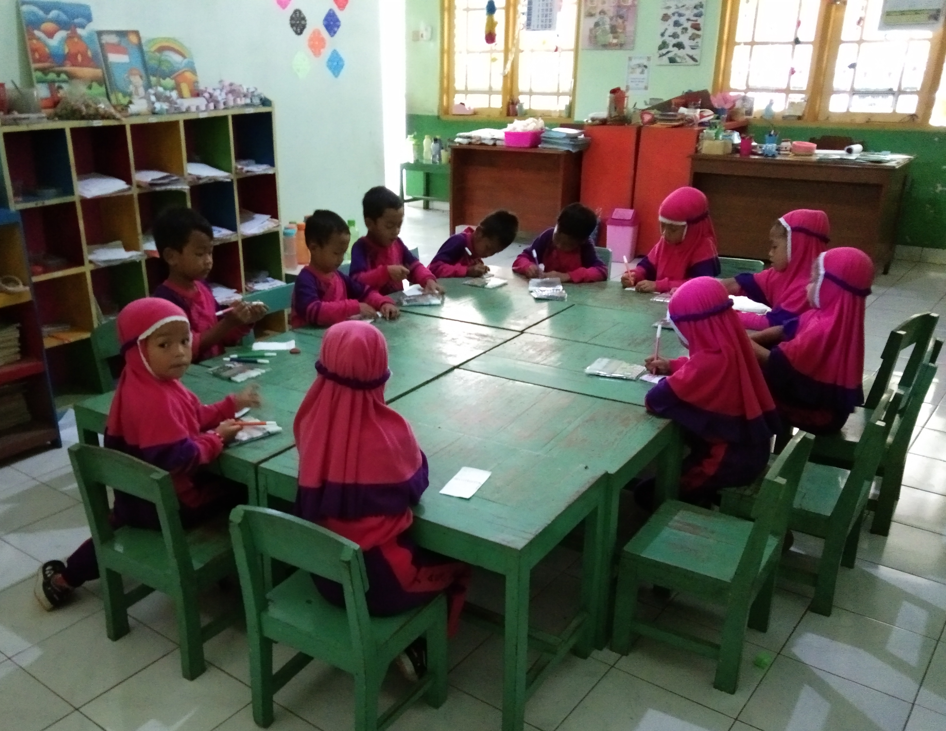
Fig 2. Implementation of teaching and learning activities

- Evaluation
Curriculum evaluations in ABA Gamplong Kindergarten are conducted by the principal on a regular basis ie every week, semester, and year by holding meetings that are measured by the achievement of objectives. For curriculum evaluation related to learning, the teacher evaluates the child by paying attention to prescribed assessment principles. Students receive the results of curriculum evaluation in the form of a book report that contains the results of student learning at school.
Evaluation of the curriculum is important because it focuses on determining the level of change that occurs in learning outcomes (behavior). The results of curriculum evaluation can be used by teachers, school principals, and education implementers in understanding and assisting student development, selecting learning materials, choosing learning methods and aids, ways of assessment and other educational facilities.[12]

Barriers and solutions
Problems that affect the implementation of curriculum management in the ABA Gamplong Kindergarten are teachers who feel overwhelmed in dealing with children who are very active so they are not focused. Children only focus on the first 5 minutes of learning, then the child will easily get bored and start looking for interesting things. To work around this, teachers must have the ability to handle children when class activities take place and appropriate time management in implementing curriculum management.
The solution, the teacher can improvise in providing material with interspersed ice breaking so that children do not get bored easily. This is consistent with the results of research conducted by Baird & Clark that the professional development model is effective in increasing teacher understanding and learning strategies by prioritizing the delivery of students' ideas and reasoning.[13]

CONCLUSION
Based on the results of the study, researchers can conclude that ABA Gamplong Kindergarten applies the 2013 curriculum so that curriculum management is carried out the same as other schools, namely curriculum planning, ABA Gamplong Kindergarten makes annual plans in the form of annual programs, semester programs, weekly activity plans and daily activity plans. Organizing is carried out by arranging the organizational structure and division of tasks. The implementation of the curriculum is based on a predetermined plan and with supervision from the school principal. Curriculum evaluation is carried out by the principal regularly on a weekly, semester and year basis by holding meetings that are measured using the achievement of objectives. For curriculum evaluation related to learning, the teacher evaluates the child by paying attention to prescribed assessment principles. What distinguishes it from other schools is the curriculum that is added to the material of the Muhammadiyah, because the school is based on Islam.
The obstacle that occurs in curriculum management in the ABA Gamplong Kindergarten is that teachers feel overwhelmed in dealing with children who are very active so they are not focused. Therefore teachers must be able to improvise in providing material and not just be encouraged by the daily activity plan.
The usefulness of this research is in managing the curriculum not only pay attention to aspects of the teacher and infrastructure but also pay attention to aspects of students.

Acknowledgment
The author would like to thank ABA Gamplong Kindergarten for the cooperation and the willingness to be location of the research. Hopefully, the later curriculum management in ABA Gamplong Kindergarten will be better.

References
- Supriyatna, I., & Hapsari, D. K. (2018, November 13). Suara.com. Retrieved from Bisnis: https://www.suara.com/bisnis/2018/11/13/165447/kualitas-sdm-indonesia-peringkat-ke-87-dari-157-negara
- Saylor, J. G., Alexander, W. M., & Lewis, A. J. (1981). Curriculum planning for better teaching and learning. New York: Holt-Rinehart and Winston.
- Harusus, Y. E. (2019, Januari 11). Pemerintah Siapkan Kurikulum Unggulan Hadapi Industri 4.0. Retrieved from Kompas.com: https://edukasi.kompas.com/read/2019/01/11/21273181/pemerintah-siapkan-kurikulum-unggulan-hadapi-industri-40.
- Yulianto, D. (2010). Bermain sambil belajar sains di taman kanak-kanak. Jakarta: PT Indeks.
- Mukminin, A. (2010). Bahan ajar Manajemen penyelenggaraan PAUD. Semarang: UNNES Press.
- Katuuk, D. A. (2014). Manajemen implementasi kurikulum: Strategi penguatan implementasi kurikulum 2013. Cakrawala Pendidikan, 13-26.
- Fikriyyah, L., & Astuti, H. P. (2017). Management school curriculum of inclusion in the kindergarten the talents of Semarang. BELIA: Early Cildhood Education Paper, 36-40.
- Sugiyono. (2013). Metode penelitian pendidikan. Bandung: Alfabeta.
- Suyadi. (2011). Manajemen PAUD. Yogyakarta: Pustaka Pelajar.
- Muflihin, H. M. (2015). Administrasi pendidikan. Klaten: CV Gema Nusa.
- Lestari, T. (2017). Implementasi Pembelajaran Berdasarkan Kurikulum 2013 di TK Negeri Pembina Singkut II Sarolangon. Jambi: FKIP Universitas Negeri Jambi.
- Adnan, M. (2017). Evaluasi kurikulum sebagai kerangka acuan pengembangan pendidikan islam. Al-Idaroh, 108-129.
- Baird, T. J., & Clark, L. E. (2018). The "look-ahead" professional development model: a professional development model for implementing new curriculum with a focus on instructional strategies. Journal Professional Development in Education, 326-341.

