Need Assessment of Online Based
Organizational Development Training
for Junior High School Principals

Rusdinal
Educational Administration Department
Universitas Negeri Padang
Padang, Indonesia
rusdinal@fip.unp.ac.id
Hanif Alkadri
Educational Administration Department
Universitas Negeri Padang
Padang, Indonesia
hanifalkadri@fip.unp.ac.id

Hade Afriansyah
Educational Administration Department
Universitas Negeri Padang
Padang, Indonesia
hadeafriansyah@fip.unp.ac.id

Abstract—This study aims to analyze the organizational development training needs for junior high school principals. This research is a descriptive study which describes data and information about analyzing the training needs of organizational development for junior high school principals. The results showed that junior high school principals were in dire need of organizational development training.
Keywords—need assessment; online base training; organizastional development;

Introduction
This template, modified in MS Word 2007 and saved as a “Word 97-2003 Document” for the PC, provides authors with most of the formatting specifications needed for preparing electronic versions of their papers. All standard paper components have been specified for three reasons: (1) ease of use when formatting individual papers, (2) automatic compliance to electronic requirements that facilitate the concurrent or later production of electronic products, and (3) conformity of style throughout a conference proceedings. Margins, column widths, line spacing, and type styles are built-in; examples of the type styles are provided throughout this document and are identified in italic type, within parentheses, following the example. Some components, such as multi-leveled equations, graphics, and tables are not prescribed, although the various table text styles are provided. The formatter will need to create these components, incorporating the applicable criteria that follow.

Theories

Selecting a Template (Heading 2)
First, confirm that you have the correct template for your paper size. This template has been tailored for output on the A4 paper size. If you are using US letter-sized paper, please close this file and download the file “MSW_USltr_format”.

Maintaining the Integrity of the Specifications
The template is used to format your paper and style the text. All margins, column widths, line spaces, and text fonts are prescribed; please do not alter them. You may note peculiarities. For example, the head margin in this template measures proportionately more than is customary.

Research Methodology
- Research Sample
No | Nama Sekolah | No | Nama Sekolah
1 | SMP N 1 Padang | 23 | SMP N 23 Padang
2 | SMP N 2 Padang | 24 | SMP N 24 Padang
3 | SMP N 3 Padang | 25 | SMP N 25 Padang
4 | SMP N 4 Padang | 26 | SMP N 26 Padang
5 | SMP N 5 Padang | 27 | SMP N 27 Padang
6 | SMP N 6 Padang | 28 | SMP N 28 Padang
7 | SMP N 7 Padang | 29 | SMP N 29 Padang
8 | SMP N 8 Padang | 30 | SMP N 30 Padang
9 | SMP N 9 Padang | 31 | SMP N 31 Padang
10 | SMP N 10 Padang | 32 | SMP N 32 Padang
11 | SMP N 11 Padang | 33 | SMP N 33 Padang
12 | SMP N 12 Padang | 34 | SMP N 34 Padang
13 | SMP N 13 Padang | 35 | SMP N 35 Padang
14 | SMP N 14 Padang | 36 | SMP N 36 Padang
15 | SMP N 15 Padang | 37 | SMP N 37 Padang
16 | SMP N 16 Padang | 38 | SMP N 38 Padang
17 | SMP N 17 Padang | 39 | SMP N 39 Padang
18 | SMP N 18 Padang | 40 | SMP N 40 Padang
19 | SMP N 19 Padang | 41 | SMP N 41 Padang
20 | SMP N 20 Padang | 42 | SMP N 42 Padang
21 | SMP N 21 Padang | 43 | SMP N 43 Padang
22 | SMP N 22 Padang

Research Instrumen/Questioner
- Instrumen Score
Klasifikasi | Score
Very suitable | 6
Appropriate | 5
Somewhat Appropriate | 4
Somewhat Inappropriate | 3
Unsuitable | 2
Very Unsuitable | 1

Level of Achievement of Respondents
- Research Data Categories
Classification | Percentage
Very good | 90-100
Good | 80-89
Enough | 65-79
Less | 55-64
Very less | 0-54

you begin to format your paper, first write and save the content as a separate text file. Keep your text and graphic files separate until after the text has been formatted and styled. Do not use hard tabs, and limit use of hard returns to only one return at the end of a paragraph. Do not add any kind of pagination anywhere in the paper. Do not number text heads-the template will do that for you.

Result and Discussion
Uraian berikut ini menyajikan deskripsi data penelitian terkait analisis kebutuhan pelatihan pengembangan organisasi berbasis online bagi Kepala Sekolah Menengah Pertama. Melalui analisis statistik deskriptif diperoleh skor tertinggi, skor terendah, rata-rata (mean), median, modus, dan standar deviasi (Sd) dari masing-masing variabel. Besaran dari skor-skor dimaksud dapat dilihat pada Tabel 1.
- Deskripsi Data
Statistics
 |  | Analisis Kebutuhan
N | Valid | 54
N | Missing | 0
Mean |  | 119.46
Median |  | 119.00
Mode |  | 116.00ª
Std. Deviation |  | 7.32
Minimum |  | 103.00
Maximum |  | 136.00
a. Multiple modes exist. The smallest value is shown
Data hasil analisis memperlihatkan bahwa distribusi skor menyebar dari skor terendah sebesar 103,00 dan skor tertinggi sebesar 136,00. Skor rata-rata (mean) sebesar 119,46 dan deviasi standar sebesar 7,32. Nilai tengah (median) sebesar 119,00, dan nilai yang sering muncul (mode) sebesar 116,00.
Dari hasil analisis dapat diketahui bahwa besar nilai rata-rata (mean), median dan mode tidak melebihi dari satu simpangan baku. Menurut Irianto (1988:58) apabila selisih nilai rata-rata, median dan modus tidak melebihi satu simpangan baku maka data tersebut cenderung normal. Sehingga dapat dikemukakan bahwa variabel Kinerja Guru berdistribusi normal. Gambaran distribusi frekuensi skor kinerja guru dapat dilihat pada Tabel 2 dan grafik histogram pada Gambar 1.
- Distribusi Frekuensi Need Assessment
Kelas Interval | Fo | %fo | Fk | %fk
132-136 | 4 | 7,41 | 2 | 7,41
127-131 | 6 | 11,11 | 8 | 18,52
122-126 | 10 | 18,52 | 18 | 37,04
117-121 | 15 | 27,78 | 33 | 64,81
112-116 | 12 | 22,22 | 45 | 87,04
107-111 | 5 | 9,26 | 50 | 96,30
102-106 | 2 | 3,70 | 52 | 100,00
Total | 54 | 100

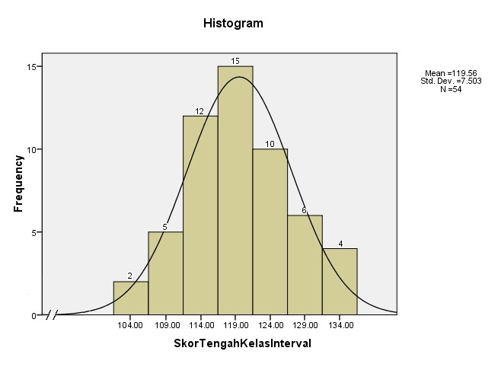
- Normality Graphic of Need Assessment

Pada Tabel 8 kelihatan bahwa 27,78% skor berada pada kelas interval skor rata-rata. Ini berarti bahwa sebagian besar skor berada pada kelas interval skor rata-rata. Selanjutnya hasil analisis tingkat pencapaian responden untuk analisis kebutuhan pelatihan pengembangan organisasi bagi kepala sekolah SMP adalah
- Tingkat Pencapaian Respon Analisis kebutuhan Pelatihan Pengembangan organisasi
No. | Indikator | Skor Ideal | Mean | % TCR | Kategori
1 | Kepala Sekolah/SDM | 40 | 34,74 | 86,80 | Sesuai
2 | Struktur Organisasi | 45 | 38,20 | 84,89 | Sesuai
3 | Pembagian Tugas | 25 | 20,91 | 83,64 | Sesuai
4 | Teknologi Informasi dan Komunikasi | 15 | 12,70 | 84,67 | Sangat Sesuai
Pada tabel 9 kelihatan bahwa tingkat capaian skor indikator yang tertinggi adalah pada indikator Teknologi Komunikasi dan Informasi sebesar 86,80% dengan kategori Sangat Sesuai dan tingkat capaian skor terendah adalah pada indikator Sumber Daya Manusian sebesar 83,64% dengan kategori Sesuai.
Secara umum tingkat capaian skor adalah 85,33% berada pada kategori sesuai. Ini berarti bahwa analisis kebutuhan terhadap pelatihan pengembangan organisasi berbasis online dilihat dari aspek Kepala Sekolah/SDM, Struktur Organisasi, Pembagian Tugas, dan Teknologi Informasi dan Komunikasi dibutuhkan bagi kepala sekolah SMP.

Conclution
Kepala sekolah SMP membutuhkan pelatihan pengembangan organisasi berbasis online pada taraf sangat sesuai.

References
- G. Eason, B. Noble, and I.N. Sneddon, “On certain integrals of Lipschitz-Hankel type involving products of Bessel functions,” Phil. Trans. Roy. Soc. London, vol. A247, pp. 529-551, April 1955. (references)
- J. Clerk Maxwell, A Treatise on Electricity and Magnetism, 3rd ed., vol. 2. Oxford: Clarendon, 1892, pp.68-73.
- I.S. Jacobs and C.P. Bean, “Fine particles, thin films and exchange anisotropy,” in Magnetism, vol. III, G.T. Rado and H. Suhl, Eds. New York: Academic, 1963, pp. 271-350.
- K. Elissa, “Title of paper if known,” unpublished.
- R. Nicole, “Title of paper with only first word capitalized,” J. Name Stand. Abbrev., in press.
- Y. Yorozu, M. Hirano, K. Oka, and Y. Tagawa, “Electron spectroscopy studies on magneto-optical media and plastic substrate interface,” IEEE Transl. J. Magn. Japan, vol. 2, pp. 740-741, August 1987 [Digests 9th Annual Conf. Magnetics Japan, p. 301, 1982].
- M. Young, The Technical Writer’s Handbook. Mill Valley, CA: University Science, 1989.

